|  |
| --- |
| **Summary of the 2012 British Columbia Sablefish (*Anoplopoma fimbria*) Research and Assessment Survey** |
| L.C. Lacko, A.R. Kronlund and M. Wyeth |
| Fisheries and Oceans Canada  Science Branch, Pacific Region  Pacific Biological Station  Nanaimo, British Columbia  V9T 6N7 |
| 2013 |
| **Canadian Technical Report of**  **Fisheries and Aquatic Sciences XXXX**  **Canadian Technical Report of Fisheries and Aquatic Sciences**  Technical reports contain scientific and technical information that contributes to existing knowledge but which is not normally appropriate for primary literature. Technical reports are directed primarily toward a worldwide audience and have an international distribution. No restriction is placed on subject matter and the series reflects the broad interests and policies of Fisheries and Oceans Canada, namely, fisheries and aquatic sciences.  Technical reports may be cited as full publications. The correct citation appears above the abstract of each report. Each report is abstracted in the data base *Aquatic Sciences and Fisheries Abstracts*.  Technical reports are produced regionally but are numbered nationally. Requests for individual reports will be filled by the issuing establishment listed on the front cover and title page.  Numbers 1-456 in this series were issued as Technical Reports of the Fisheries Research Board of Canada. Numbers 457-714 were issued as Department of the Environment, Fisheries and Marine Service, Research and Development Directorate Technical Reports. Numbers 715-924 were issued as Department of Fisheries and Environment, Fisheries and Marine Service Technical Reports. The current series name was changed with report number 925.  **Rapport technique canadien des sciences halieutiques et aquatiques**  Les rapports techniques contiennent des renseignements scientifiques et techniques qui constituent une contribution aux connaissances actuelles, mais qui ne sont pas normalement appropriés pour la publication dans un journal scientifique. Les rapports techniques sont destinés essentiellement à un public international et ils sont distribués à cet échelon. II n'y a aucune restriction quant au sujet; de fait, la série reflète la vaste gamme des intérêts et des politiques de Pêches et Océans Canada, c'est-à-dire les sciences halieutiques et aquatiques.  Les rapports techniques peuvent être cités comme des publications à part entière. Le titre exact figure au-dessus du résumé de chaque rapport. Les rapports techniques sont résumés dans la base de données *Résumés des sciences aquatiques et halieutiques.*  Les rapports techniques sont produits à l'échelon régional, mais numérotés à l'échelon national. Les demandes de rapports seront satisfaites par l'établissement auteur dont le nom figure sur la couverture et la page du titre.  Les numéros 1 à 456 de cette série ont été publiés à titre de Rapports techniques de l'Office des recherches sur les pêcheries du Canada. Les numéros 457 à 714 sont parus à titre de Rapports techniques de la Direction générale de la recherche et du développe­ment, Service des pêches et de la mer, ministère de l'Environnement. Les numéros 715 à 924 ont été publiés à titre de Rapports techniques du Service des pêches et de la mer, ministère des Pêches et de l'Environnement. Le nom actuel de la série a été établi lors de la parution du numéro 925 |

Canadian Technical Report of

Fisheries and Aquatic Sciences XXXX

2016

SUMMARY OF THE 2012 BRITISH COLUMBIA SABLEFISH (*Anoplopoma fimbria*) RESEARCH AND ASSESSMENT SURVEY

by

L.C. Lacko1, A.R. Kronlund1 and M. Wyeth1

1Fisheries and Oceans Canada

Science Branch, Pacific Region

Pacific Biological Station

Nanaimo, British Columbia

V9T 6N7

© Her Majesty the Queen in Right of Canada, 2016.

Cat. No. Fs 97-6/2694E ISSN 0706-6457

Correct citation for this publication:

Lacko, L.C., Kronlund, A.R. and Wyeth, M. 2016. Summary of the 2012 British Columbia sablefish (*Anoplopoma fimbria*) Research and Assessment Survey. Can. Tech. Rep. Fish. Aquat. Sci. XXXX: xx + xxx p.

**Table of contents**

Table of contents v

List of Figures viii

List of Appendices x

ABSTRACT xi

RESUMÉ xiii

1.0 INTRODUCTION 1

2.0 METHODS 2

2.1 CHARTERED VESSEL AND SET LOCATIONS 2

2.2 STRATIFIED RANDOM SAMPLING SURVEY COMPONENTS 3

2.3 TRADITIONAL SURVEY COMPONENTS 3

2.4 VANCOUVER ISLAND INLETS EXPLORATORY COMPONENT 4

2.5 BENTHIC IMPACTS STUDY 4

2.6 FISHING GEAR 4

2.7 DATA COLLECTION DURING GEAR DEPLOYMENT 5

2.8 CATCH AND EFFORT DATA COLLECTION 5

2.9 CATCH PROCESSING 6

2.10 ELECTRONIC MONITORING (EM) VIDEO DATA COLLECTION 8

2.11 OCEANOGRAPHIC SAMPLING DATA COLLECTION 8

2.12 BENTHIC IMPACTS STUDY DATA COLLECTION 9

3.0 RESULTS AND DISCUSSION 9

3.13 CATCH RATES 9

3.14 CATCH COMPOSITION 11

3.15 SABLEFISH SAMPLING AND TAGGING 12

3.16 OTHER SPECIES SAMPLING and tagging 12

3.17 RECOVERED TAGGED SABLEFISH 13

3.18 SABLEFISH AGES 13

3.19 OCEANOGRAPHIC TEMPERATURES AND DEPTHS 14

3.20 BENTHIC IMPACTS STUDY 15

4.0 ACKNOWLEDGEMENTS 15

5.0 REFERENCES 16

**List of Tables**

Table 1. Components of the 2012 Sablefish research and assessment survey. 18

Table 2. British Columbia Sablefish research and assessment surveys, 1988 to 2012. 19

Table 3. Count of random set locations selected from the set of 2x2km grid cells, within the five spatial strata (S1-S5) and three depth strata (RD1-RD3) for all years the random survey component has been conducted. The five spatial strata are shown in Figure 1. The depth strata include RD1 (100-250 fathoms), RD2 (250-450 fathoms) and RD3 (450-750 fathoms). 20

Table 4. Geographic boundaries of the five spatial strata (S1-S5). 21

Table 5. List of localities visited in the traditional component of the Sablefish research and assessment surveys from 1988 through 2012. Standardized sets (light blue boxes and half boxes) were conducted in offshore indexing localities from 1988 to 2010. Sablefish were tagged and released (dark blue half boxes) from standardized sets at offshore indexing localities beginning in 1991 and ending in 2007. Offshore tagging localities where only traditional tagging sets (red boxes) occurred were added in 1995 and were discontinued in 2008. Mainland Inlet localities where standardized sets (green boxes) were conducted began in 1994 and continued through to 2012. 22

Table 6. List of the number of standardized (S) and exploratory (E) sets completed at each locality (mainland inlet and exploratory) for the 2003 to 2012 Sablefish research and assessment surveys. 23

Table 7. Geographic boundaries of the set locations within each mainland inlet locality. Each set location was defined as the area enclosed by the polygon with vertices at each of the four or five indicated points. 24

Table 8. Summary of species captured during the 2012 survey Type 3 tagging sets (StRS design) conducted by the Ocean Pearl. No value in the weight column indicates that the catch was not weighed. Trace indicates a total weight of less than 1 kg. 25

Table 9. Summary of species captured by the Ocean Pearl during the 2012 survey standardized sets conducted at mainland inlet localities. Null values indicate the catch was not counted or weighed. Trace indicates a total weight of less than 1kg. 27

Table 10. Total count and weight of species captured during the 2012 survey at the exploratory sites. Null values indicate that the catch was not counted or weighed. Trace values indicate a total weight of less than 1 kg. Scientific names are listed with binomial nomenclature or genus name. 28

Table 11. Counts of Sablefish tagged, recovered and sampled at stratified random sites by spatial and depth stratum during the 2012 Sablefish research and assessment survey. The depth intervals for RD1, RD2 and RD3 are 100-250 fathoms, 250-450 fathoms and 450-750 fathoms, respectively. 29

Table 12. Count of tagged and sampled Sablefish at mainland inlet localities and exploratory sites during the 2012 Sablefish research and assessment survey. Tagged Sablefish counts are listed by released fish, recovered fish (re-released, deceased, escaped), and fork length measurements. Sampled Sablefish counts are listed by fork length, sex, maturity, otolith and weight. 30

Table 13. Summary of Sablefish biological data collected in the 2012 stratified random design component. The counts exclude recovered tagged fish. 31

Table 14. Summary of Sablefish biological data collected in the 2012 mainland inlet localities and exploratory sites. The counts exclude recovered tagged fish. 31

Table 15. Details of biological data collected from species other than Sablefish, Rougheye Rockfish and tagged Spiny Dogfish during the 2012 survey. The number of fish samples taken for length and sex, the total specimen count, and proportion of males vs. females are listed by species and set number. The length type is specified for each species with the mean length in millimetres listed by males, females and those either not determined or not sexed (n/a). 32

Table 16. List of the North Pacific spiny dogfish tagged with pop-off satellite tags. The tube label and tag number identify the dogfish. The GFBIO specimen identifier is included for database reference. 42

Table 17. Details of biological data collected from Rougheye Rockfish during the 2012 survey. 43

Table 18. Count of tagged fish released since 1991 (including re-released) and counts of verified tag recoveries by year until Jan 2013 including any recoveries that had no reported year (n/a). The total count of tag recoveries represent the sum of all verified recoveries. 44

Table 19. Counts of tagged fish recoveries by Groundfish management unit area (GMU). These areas are posted in the inset of Figure 1. 45

**List of Figures**

Figure 1. Location of the boundaries of the mainland inlet localities, one exploratory site and the five spatial areas (S1-S5) of the stratified random survey design. The three depth strata (RD1-RD3) are colour-coded, nested within each of the five spatial strata. The inset shows the Groundfish Management Unit (GMU) areas. 46

Figure 2. Start locations of the 2012 survey sets (red markers) conducted in the stratified random survey areas S1 and S2 and survey sets conducted (purple markers) in the exploratory area. The camera sets are represented by yellow markers. 47

Figure 3. Start locations of the 2012 survey sets (red markers) conducted in the stratified random survey areas S3 and S4. 48

Figure 4. Start locations of the 2012 survey sets (red markers) conducted in the stratified random survey area S5. 49

Figure 5. Location of the traditional survey sets at the Portland Inlet mainland locality 2003 through 2012. 50

Figure 6. Location of the traditional survey sets at the Gil Island mainland inlet locality 2003 through 2012. 51

Figure 7. Location of the traditional survey sets at the Finlayson Channel mainland inlet locality 2003 through 2012. 52

Figure 8. Location of the traditional survey sets at the Dean/Burke Channel mainland inlet locality 2003 through 2012. 53

Figure 9. Individual components of the survey fishing gear. 54

Figure 10. Distribution of catch rates for Type 3 tagging sets summarised by a boxplot for each depth stratum by year (2003-2012). Each panel shows catch rates grouped by depth strata from shallow to deep (RD1-RD3) for each year the StRS survey was conducted. The filled circles show the mean catch rates for each depth stratum. 55

Figure 11. Distribution of catch rates for Type 3 tagging sets summarized by a boxplot for each spatial stratum by year (2003-2012). Each panel shows catch rates grouped by spatial strata from south to north (S1- S5) for each year the StRS survey has taken place. The filled circles show the mean catch rates in each stratum 56

Figure 12. Graph of mean catch rates by year for StRS design Type 3 tagging sets summarised for each spatial stratum (S1-S5) . The inset shows the location of the five spatial strata. 57

Figure 13. Distribution of catch rates summarised by boxplots for standardized sets conducted at mainland Inlet localities, standardized sets conducted at Offshore 58

Figure 14. Sablefish length frequency (cm) for males and females for the 2012 survey. The specimen counts are represented by the symbol n, the mean length by the xbar symbol, , and the standard deviation by the symbol σ. 59

Figure 15. Sablefish fork length (L in cm) vs weight (W in kg) for males and females for the 2012 survey, where W=aLb. 60

Figure 16. Bubble plot for female Sablefish ages by survey year (1988-2011). The width of the circles are proportional to the number of aged fish. For each year, the age with the highest proportion is listed to the right. The number (n) of fish aged at the time of this report are stated at the top of the panel. 61

Figure 17. Bubble plot for male Sablefish ages by survey year (1988-2011). The width of the circles are proportional to the number of aged fish. For each year, the age with the highest proportion is listed to the right. The number (n) of fish aged at the time of this report are stated at the top of the panel. 62

Figure 18. Coplot of average depth(m) vs average temperature (ºC) for a given 1-degree latitude intervals (blue bands) for 2007 and 2008. The number of fishing sets deployed with a SBE 39 recorder are represented by n. 63

Figure 19. Coplot of average depth(m) vs average temperature (ºC) for a given 1-degree latitude range (blue bands) for 2009 and 2010. The number of fishing sets deployed with a SBE 39 recorder are represented by n. 64

Figure 20. Coplot of average depth(m) vs average temperature (ºC) for a given 1-degree latitude range (blue bands) for 2011 and 2012. The number of fishing sets deployed with a SBE 39 recorder are represented by n. 65

Figure 21. Average temperatures as reported from the Sea-bird SBE 39 loggers at 1-degree latitude intervals and three depth intervals: 100-250 fathoms (183 to 457 meters), 250-450 fathoms (458-823 meters) and 450-750 fathoms (824-1372 meters). 66

Figure 22. Accelerometer graphs of g-force (m/s2) over time for bottom sensors in trap 1 (a.), 5(b.), 10(c.), 15(d.), 20(e.) and 25(f). The arrows on each graph mark the time of the last anchor being set over the stern and the first anchor hauled aboard. 67

Figure 23. Location of the epicentre of a 7.7 magnitude earthquake on Saturday October 27, 2012 at 8:04 p.m. The inset shows the accelerometer reading that captured the earthquake event. 69

**List of Appendices**

Appendix A. Details of sets completed during charter 1 of the 2012 survey program (F/V Ocean Pearl). 70

Appendix B. Diagram of the F/V Ocean Pearl deck and survey activities. 76

Appendix C. Example data forms used during the 2012 Sablefish survey. 77

Appendix D.Summary trap use for each set in the 2012 Sablefish survey. 91

Appendix E. Example of a temperature and pressure data plotted over time with Sea-Bird Electronics© Plot 39 software. 96

Appendix F. Conversion of pressure to depth documentation from the Sea-Bird application note No.69. http://www.seabird.com/application_notes/an69.htm. 97

Appendix G. Instructions for deployment and uploading data from the Nuytco autonomous camera system. 98

Appendix H. Example of a plot using HOBOware© Lite Software. The data table displays the date, time, X, Y and Z acceleration in units of g-force (m/s2). The graph shows the x, y and z readings over time, with the time of the last anchor being set over the stern and the first anchor hauled aboard marked between the arrows. 104

Appendix I. Details on Sablefish catch and numbers recovered, sampled and tagged during the 2012 charter. 105

Appendix J. Trap Gear Glossary. 109

**ABSTRACT**

Lacko, L.C., Kronlund, A.R. and Wyeth, M. 2013. Summary of the 2012 British Columbia Sablefish (*Anoplopoma fimbria*) Research and Assessment Survey. Can. Tech. Rep. Fish. Aquat. Sci. XXXX: xx + xxx p.

This document describes sampling activities and results from the 2012 British Columbia Sablefish research and assessment survey. It is intended to provide historical reference and a detailed summary of accomplishments to inform end users and researchers.

This survey continued the same three sampling strategies and longline trap gear used in surveys since 2003. Sampling strategies included stratified random sampling (StRS), sampling at all traditional inlet sites, and sampling at one exploratory area. The random component included StRS sets at five depth-stratified areas and the traditional component included standardized sets at four inlet localities on the mainland. The exploratory component included two sets in a northern Vancouver Island inlet to evaluate Sablefish density and/or size compositions. A benthic impact study was also initiated where digital images were collected to assess the impact of longline trap gear on the benthic habitat. In this study, bottom contact sensors and video cameras were also used to directly to survey trap gear at pre-selected sites.

As in previous surveys, biological sampling for Sablefish included length, weight, sex, maturity and age. Sablefish were systematically randomly sampled from every third trap at StRS stations, collecting a maximum sample size of 50 Sablefish. Sablefish samples were collected from every-other trap on traditional sets to gain a sample size of 50-75 fish. Biological samples were collected from one third of all exploratory traps. Biological samples (length, sex) of all non-Sablefish species were taken from catch in all traps. In addition, Rougheye/Blackspotted Rockfish samples included length, weight, sex, maturity, ages and genetic samples from all catch.

A Sablefish tag and release study has been conducted annually since 1991 and was continued in 2012. Sablefish were selected randomly for tag and release from every third trap at StRS sites and from every second trap at the traditional inlet localities. Additionally, a cooperative tag and release study for Spiny Dogfish with Auke Bay Laboratories (NMFS) was conducted. Only Spiny Dogfish with a pre-caudal length greater than seventy centimetres were tagged with pop-off satellite tags to collect location information to inform stock movement patterns.

In total, 23,060 Sablefish were caught, of which 8,574 were tagged and released and 5,683 were used for biological samples, with the remainder being released. There were 151 tagged fish recaptured that were fitted with a new tag and were re-released, and one previously tagged fish that was retained for biological sampling.

Other than Sablefish, sixty-four taxonomic groups were represented in the catches during the StRS (Type 3 tagging) sets. Twenty-nine taxonomic groups were represented in the catches from traditional standardized sets conducted at mainland inlet localities and two taxonomic groups were represented in the catches at the exploratory sites. Over 13,790 biological samples were collected from non-Sablefish species in 38 taxonomic groups. A total of 395 genetic samples were collected from the Rougheye/Blackspotted rockfish complex.

Catch rates are an important product from this survey that can be used to infer population trends, which are critical data elements used in stock assessment. Catch rates from stratified random sets in the shallow depth stratum have shown a gradual decline from 2003 to 2009, increasing in 2010 and 2011 and decreasing in 2012. Catch rates in the middle depth stratum declined between 2003 and 2010, increased in 2011, and decreased in 2012. Catch rates from the deep depth stratum increased between 2003 and 2006, were variable in the preceding three years and increased in both 2010 and 2011 and decreased again in 2012. Between 2008 and 2011, traditional standardized sets at mainland inlet locations showed a steady increase in catch rates and in 2012, the catch rate dropped to 2010 levels.

**RESUMÉ**

Lacko, L.C., Kronlund, A.R. and Wyeth, M. 2016. Summary of the 2008, 2009, 2010 and 2011 British Columbia Sablefish (*Anoplopoma fimbria*) Research and Assessment Survey. Can. Tech. Rep. Fish. Aquat. Sci. XXXX: xx + xxx p.

Ce document…….

1. INTRODUCTION

Sablefish are currently managed in BC as part of the Integrated Fisheries Management Plan (IFMP), under the commercial licence category K or communal commercial licence category FK. For the past six years (2007 to 2012), Sablefish landings by British Columbia fishermen have averaged approximately 2,600 metric tons annually for trap, hook and line and trawl gear. Most of the fish were captured by longline trap gear (~48%) and longline hook gear (~42%). Fisher-log records plotted in a GIS (Geographic Information Systems) show that the commercial harvest of Sablefish typically occurs along the steep-walled slopes off the west coast of Haida Gwaii, in complex troughs of the Queen Charlotte Sound area, and in the steep canyons and ridges of the West Coast of Vancouver Island, at depths of up to 985 fathoms.

Fishery-independent research and assessment surveys have been conducted for Sablefish *(Anoplopoma fimbria)* since 1988 in the waters off the west coast of Haida Gwaii (formerly Queen Charlotte Islands), south to Vancouver Island, British Columbia. Survey procedures have been developed over time, but each year, the surveys have consisted of fishing sets using trap gear at selected sites. These surveys serve to obtain catch rate data for assessing stock abundance, to gather biological sample records, monitor oceanographic data, and to collect tag release and recapture data.

Historically, the traditional component of the Sablefish survey included “standardized” fishing sets that were conducted within geographic boundaries named “offshore indexing localities” (1990 through 2010). In the 1991 survey, Sablefish were tagged and released during these standardized fishing sets. The research and assessment survey in 1995 included the addition of six new geographic boundaries named “offshore tagging localities”, or areas dedicated exclusively for conducting “traditional tagging” sets. Over the next 13 years (1995 through 2007), revisions were made to the suite of offshore tagging localities. Commencing in 1994, the traditional component of the Sablefish survey also included standardized sets at mainland inlet localities. In 2003, the stratified random sampling (StRS) design was introduced. StRS sets were conducted within 2 x 2 km grid cells, nested in five depth-stratified areas along the continental shelf of British Columbia. A historic overview of the design of Sablefish surveys is provided by Wyeth et al. (2008), Wyeth and Kronlund (2003) and Wyeth et al. (2004b). Specific details about surveys conducted from 1988 through 1993 are provided by Smith et al. (1996); surveys in 1994 and 1995, by Downes et al. (1997); and surveys from 1996 to 2000 by Wyeth and Kronlund (2003). For the 2001 through 2007 surveys see Wyeth et al. (2003, 2004a, 2004b, 2006, 2007, 2013 respectively). The technical report for the 2008 through the 2011 surveys is provided by Lacko et al (2013).

This technical report describes sampling activities and summarizes the data collected during the 2012 chartered survey aboard the FV Ocean Pearl.

1. METHODS

The methodology for the 2012 Sablefish research and assessment survey included a stratified random sampling design component, a traditional component, an exploratory component and a benthic impacts study. Survey components, bait methods, locality names and sampling protocols are summarized in Table 1.

For the stratified random sampling design component, StRS fishing sets were conducted in randomly chosen 2x2km grid cells, nested within five spatial strata and three depth strata (Figure 1). The random design was used first on the 2003 survey, with the purpose of distributing tag releases at random, collecting biological samples and developing a catch-rate based index of abundance. It provided an alternative design to be used in addition to the historic traditional component used on surveys from 1990 to 2010.

Standardized fishing sets conducted as part of the traditional component of the survey used specific gear and sampling protocols. The purpose of the standardized sets were to collect catch rate data in order to index trends in abundance, tag fish and obtain biological samples. Standardized fishing sets occurred within mainland inlet localities. The geographic boundaries of these localities are shown in Figure 1.

Fishing sets for the exploratory component of the survey were used to evaluate Vancouver Island inlets that have not been surveyed for Sablefish density and/or size composition. The boundaries of the exploratory sites are also shown in Figure 1.

In order to evaluate the impact of fishing gear on the benthic habitat, camera sets were initiated during the 2012 Sablefish research and assessment survey. Nuytco autonomous camera systems were attached to traps to capture video and still images. In addition, accelerometers were deployed on many sets to gather trap orientation and movement data.

* 1. CHARTERED VESSEL AND SET LOCATIONS

The F/V Ocean Pearl, skippered by D. Nicols, completed a total of 135 sets between October 9 and November 17, 2012. Table 2 lists all the Sablefish research and assessment surveys conducted from 1988 to 2012. This table includes a unique identifier (UID) required to reference the trip data stored in the Fisheries and Oceans Pacific Groundfish database, GFBIO.

The geo-referenced boundaries of the 5 spatial areas (S1-S5) with colour coded depth strata (RD1-RD3) of the stratified random survey design and the location of the mainland inlet localities are shown in Figure 1. Individual 2012 survey locations for sets 1 to 115 are plotted over shaded relief maps of the seafloor in Figure 2 to 4. Each location is identified by a colour as either 1) a stratified random survey set; 2) an exploratory set; or 3) a camera set. The traditional survey localities (mainland inlets) and set line locations for sets 116 to 135 are shown in Figures 5 to 8. Detailed information collected for each set are presented in Appendix A.

* 1. STRATIFIED RANDOM SAMPLING SURVEY COMPONENTS

The main component of the 2012 survey employed a stratified random sampling design (StRS). Grid cells measuring 2 by 2 square kilometers were nested in each of five spatial strata (S1 to S5) and three depth strata (RD1 to RD3). The three depth ranges included 100-250 fathoms, 250-450 fathoms and 450-750 fathoms.

Historically, from 2003 through 2005, five grid cells were randomly selected in each spatial-depth stratum. Then from 2006 through 2010, the number of grid cells randomly selected in each spatial-depth stratum was increased to six. Later, in 2011 and 2012, the grid cells were randomly chosen based on area and catch numbers (Table 3).

The geographic boundaries of the five spatial strata (S1-S5) for StRS sets are listed in Table 4 and are plotted in Figures 2 to 4.

* 1. TRADITIONAL SURVEY COMPONENTS

The traditional survey component in 2012 included conducting standardized sets with specific bait and gear requirements at four mainland inlet localities. A list of historic offshore indexing and tagging localities and a timeline marking the notable changes in these traditional components over the survey years is presented in Table 5. Sets were conducted in offshore indexing localities from 1988 through to 2010 and offshore tagging localities were conducted at these sites from 1996 through to 2007. Five survey sets at mainland inlet localities began in 1994 and are still in effect (Table 6). In 2003, five distinct geographic boundaries were delineated and described for each locality (Table 7).

* + 1. Portland Inlet Mainland Inlet Locality

Portland Inlet was the most northern mainland inlet locality. It is located just north of Prince Rupert and is approximately 40 kilometers long. As in previous years, five standardized sets were conducted at this site during the 2012 survey (Table 6). The geo-referenced set polylines in Portland Inlet from 2003 to 2012 are plotted in Figure 5. Trap gear was deployed near the center of each polygon in order to avoid the steep slopes characteristic of this British Columbian fjord. The geographic coordinates for the five polygons that make up this locality are presented in Table 7.

* + 1. Gil Island Mainland Inlet Locality

The Gil Island locality is located south west of Kitimat and is situated in the entrance to Douglas Channel. As in previous years, five standardized sets were conducted at the Gil Island locality during the 2012 survey (Table 6). The geo-referenced set polylines in Gil Island from 2003 to 2012 are shown in Figure 6. Trap gear was deployed near the center of each polygon in order to avoid the steep slopes characteristic of Douglas Channel. The geographic coordinates for the five polygons that make up Gil Island locality are presented in Table 7.

* + 1. Finlayson Channel Mainland Inlet Locality

The Finlayson Channel locality extends north of Milbanke Sound and west of Roderick Island. As in previous years, five standardized sets were conducted at the Finlayson Channel locality during the 2012 survey (Table 6). The geo-referenced set polylines in Finlayson Channel from 2003 to 2012 are plotted in Figure 7. Trap gear was deployed near the center of each polygon in order to avoid the steep slopes found in Finlayson Channel. The geographic coordinates for the five polygons that make up the boundaries are presented in Table 7.

* + 1. Dean/Burke Channel Mainland Inlet Locality

Dean Channel extends north east from Fisher Channel on the north side of King Island and west of Bella Coola. Burke Channel is on the south side of King Island and south west of Bella Coola. As in previous years, five standardized sets were conducted at the Dean/Burke Channel locality during the 2012 survey (Table 6). The geo-referenced set polylines in Dean/Burke Channel from 2003 to 2012 are shown in Figure 8 and the geographic coordinates of individual polygons are presented in Table 7.

* 1. VANCOUVER ISLAND INLETS EXPLORATORY COMPONENT

To assess those areas that have not previously been surveyed for Sablefish density and/or size composition, two exploratory sets were conducted in a Vancouver Island inlet near Quatsino Sound (Table 6). These two sets (Figure 2, right panel) were conducted in the immediate vicinity of the two exploratory sets that were done in the 2011 survey.

* 1. BENTHIC IMPACTS STUDY

In order to evaluate the impacts to benthic habitat when the trap gear contacts the sea-floor bottom, three preliminary video sets were conducted in order to identify the optimal video angles and footage needed from the underwater cameras. The locations of the video sets are represented by yellow markers in Figure 2, left panel.

* 1. FISHING GEAR

As in previous surveys, a set of longline trap gear consisted of a line resting on the ocean floor (groundline) with 25 baited traps attached to beckets at 46 m intervals along its length. The bait methods for each survey component are listed in Table 1. Individual components of the fishing gear are shown in Figure 9. See Wyeth and Kronlund (2003) and Figure 9 for a more detailed description of the survey fishing gear and setting and hauling procedures.

* 1. DATA COLLECTION DURING GEAR DEPLOYMENT

A deck diagram for the F/V Ocean Pearl shows the specific locations where data was recorded in 2012, and how the deck space was used for sorting and sampling the catch (Appendix B). At the time of deployment,, a set log data form (Appendix C, example Figure C. 1) and a bridge log data form (example, Figure C. 2) were completed by science staff members.

The set log data form was filled out on the deck near the stern setting table where the recorder had maximum visibility of the crew setting the gear. The time was logged when the 1st and 2nd buoys, and the 1st and 2nd anchors were deployed. Each of the 25 traps were counted and inspected as they were deployed over the stern rail. Any missed beckets, extra traps, unclosed escape rings and web damage were noted. The recorder noted the bait type, weight, and method (i.e. bagged bait or loose bait). When each third trap was deployed, the recorder ensured that a Seabird SBE 39 temperature and pressure logger was inside and logged its serial number. The comments section on the set log was used to record the accelerometer serial number, the colour of string attached to the accelerometer, and the associated trap number.

During the deployment of the gear, a second recorder in the wheelhouse completed the bridge log data form. First, the set details were entered. For random tagging sets, the spatial stratum, depth stratum and grid cells (box number) were recorded. For exploratory or inlet sets, the location/locality name was logged. The start and end positions of each set were entered at the time when the first and last anchors were set over the stern for every set. These geo-referenced positions were obtained from Nobeltec Navigation © software running on the bridge computer, delivered electronically through a NMEAdata string. The start and end bottom depths were logged from the vessel’s depth sounder when the first and last anchors were set. Depths were recorded from the vessel’s depth sounder at one-minute intervals between the first and last anchors being set. Later, the average of these depths would be used to calculate the mean setting bottom depth. The time at the deployment of the first buoy and anchor were logged, as well as the time at the retrieval of the second buoy and anchor. Later, the duration of the set was calculated as the time elapsed between the first anchor being set over the stern and the first anchor hauled aboard.

* 1. CATCH AND EFFORT DATA COLLECTION

The charter catch log data form (example, Figure C. 2) was completed during hauling by the science staff recorder positioned at the Marel M1100 scale (Appendix B). Each trap number, trap use code (D=dump, A=age sample, B=length sex maturity sample, T=tag sample, MT=empty trap), and trap species counts and weights were recorded. The code TR was entered to indicate any trace values for those species with a total weight of less than 1 kg. Crew members would alert the recorder about any damage to a trap (i.e. holes) and later make the necessary repairs to the trap before it was set again. The Seabird SBE 39 serial number was noted with the trap number in which it was contained. Times were logged during hauling when the 1st and 2nd buoy and the 1st and 2nd anchor came aboard.

Effort data was calculated by using the number of traps fished for each set including holed or fouled traps and excluding open traps. Effort was also calculated by recording the time elapsed between the deployment of the first anchor set and retrieval of the first anchor hauled.

Data recorded on the catch log forms (example, Figure C. 3) were later transcribed to a more legible format on the tabular catch log data entry form (example, Figure C. 4). Here, records of damaged traps were converted to trap usability codes and records of how catch weights were determined were converted to catch verification codes.

* 1. CATCH PROCESSING
     1. Biological Samples

Biological sampling forms were completed for Sablefish specimens in the 2012 survey. Measurements were completed for fork length (L) (tip of the snout to the end of the middle caudal fin ray), whole body weight (W), sex (S) and maturity level (M). Sagittal otoliths (O) were collected and stored for determination of ages in the lab. All legal-sized Sablefish (fork length > 55 cm) that were sacrificed for biological samples were then dressed, frozen, and landed as commercial catch.

An example of a completed Sablefish biological sampling form (LSWMO) is shown in Figure C. 5. Biological sampling forms were also completed for specimens other than Sablefish. Measurements taken were species specific length (L) and sex (S). Figure C. 6 shows an example of a completed LSS (length, sex, species) form.

A separate biological sampling form was completed for the Rougheye/ Blackspotted Rockfish complex. Since Rougheye and Blackspotted Rockfish have similar appearances with slight variations in colour markings and dorsal fin spine lengths, the sampler tried to visually identify each specimen as either Rougheye (RE) or Blackspotted (BS). In addition, tissue for DNA extraction was collected (into vials containing 95% ethanol), and vial numbers were recorded for subsequent genetic determination of the Rougheye/Blackspotted Rockfish complex.

Figure C. 7 shows an example of a completed biological sampling form for the Rougheye/Blackspotted Rockfish complex used to record length, sex, weight, maturity, otolith and DNA samples (LSWMODNA). Figure C. 8 shows the rockfish maturity convention used to determine the Rougheye or Blackspotted Rockfish gonad condition. Figure C. 9 shows the specification form used by the sampler to distinguish between the Rougheye and Blackspotted species.

* + 1. Tagging Sablefish

Fish to be tagged were transferred from the sorting area to the tagging tank (deck map, Appendix B). The tank temperature was recorded with a Sea-Bird SBE 39 temperature and pressure logger. Fish were removed from the holding tank by the sampler and fork length (mm) measurements were entered on the tagging form by the recorder. Next, the sampler inserted a tag with a unique identifier (UID) on the left side of each fish, 1 cm below and 2-3 cm behind the anterior insertion of the first dorsal fin. A Mark II Long Tagging gun loaded with Floy FD-94 T-bar anchor tags was used to tag fish. At the time of tagging, any sampling errors, injuries or damage to the fish were documented on the tagging form with a letter code. These codes are listed on the tagging form example (). Tag checks were performed systematically by the recorder to ensure tag numbers on the data form matched those on the fish specimen.

* + 1. Recovered Tagged Sablefish

A previously tagged fish that was brought aboard may have been treated in one of several ways. First, the tagged fish may have been re-released with a new tag, and the previous tag removed. Second, the tagged fish may have been retained for biological sampling if it had a tag from another country, or if it had sustained numerous injuries. The Department returns those tags released by foreign agencies. The release agency can usually be determined from the tag prefix and colour. Figure C. 11 shows an example of a completed recovered Sablefish sampling form with an inset image of a recovered tag.

* + 1. Tagging North Pacific Spiny Dogfish

In each spatial stratum, several spiny dogfish with intact first dorsal spines and pre-caudal lengths greater than seventy centimetres were tagged with pop-off satellite tags for Auke Bay Laboratories movement studies. First, the recorder noted the set number, tag number, pre-caudal length and sex on the data sheet. The sampler then drilled a horizontal hole through the first dorsal spine and inserted a piece of monofilament that was attached to a pop-off satellite tag. The monofilament was secured with a crimping sleeve. Once the spiny dogfish had been observed in the recovery tank for a few minutes, it was released over the side of the boat. Figure C. 12 shows an example of a completed spiny dogfish tagging form used on the 2012 survey. Figure C. 13 shows the pop-off satellite tag instruction form used by the sampler.

* + 1. Catch Processing at Random StRS design Type 3 Tagging Sets

Type 3 tagging sets used a sampling protocol that assigned a fate to the Sablefish catch in each trap, dividing the 25 traps so that 1/3 of the traps were used for tagging (T), 1/3 were used for biological sampling (A) and 1/3 were released alive (D). The catch recorder assigned the first trap with a random code (D, A or T), then proceeded to assign the rest of the traps with the remaining codes in sequential order (D, A, T). Any traps that had no Sablefish catch were marked with a code for empty trap (MT). The aim for a type 3 tagging set was to obtain a maximum 50 piece LSWMO biological sample from traps selected along the entire length of the string. In cases where sets had huge catches and the 50 piece sample goal would be quickly reached, traps that were assigned a fate of biological sample (A) were simply re-allocated to be released alive or discarded (D). On the other hand, sets with little catch that had traps assigned to be released alive (D) were re-allocated to a biological sample (A) in order to be able to achieve the 50 piece sample goal. The use of the Sablefish catch in the 2012 survey for each trap by StRS set is listed in Appendix D. This appendix includes the total counts of traps within a set by trap use.

* + 1. Catch Processing At Mainland Inlet Localities

All the Sablefish from traps selected for tagging (T) were tagged. The Sablefish from the remaining traps (odd-numbered traps for even-numbered sets and even-numbered traps for odd-numbered sets) were used to obtain a LSWMO sample of at least 50 fish per set. Fish in excess of the biological sampling requirements were released alive. Catch recorders attempted to spread the traps selected for the biological samples along the entire length of the string.

The use of the Sablefish catch in each trap by inlet set is listed in Appendix D with set numbers highlighted in green. This appendix includes total counts of traps within a set by trap use. Fishing at mainland inlet localities occurred from November 10 to November 15, during sets 116 to 135.

* 1. ELECTRONIC MONITORING (EM) VIDEO DATA COLLECTION

At the time of hauling gear, the vessel’s electronic monitoring (EM) system cameras were activated by the skipper. Three internet protocol (IP) cameras and three standard analog cameras were positioned at optimal viewing angles to record the survey activities. IP camera 6 and analog cameras 1 and 3 were positioned along the mast to record the catch as it was processed at the hopper. IP camera 5 and analog camera 2 were positioned on the starboard to record the traps as they were brought over the rail. Last, IP camera 4 was positioned over the tagging tank. The video data from each set was reviewed by the catch recorder and an assistant shortly after the set to allow for quality control prior to the electronic catch data entry process.

* 1. OCEANOGRAPHIC SAMPLING DATA COLLECTION

A Sea-bird SBE 39 temperature and pressure logger was placed in a protective plastic pipe and was attached to the inside of the third trap during gear deployment. Typically, the data from the Sea-bird SBE 39 was immediately downloaded after hauling using the Sea-Bird Electronics SeaTerm © software. The standard Sea-Bird data files contained sample data in the form of temperature, pressure, date and time.

Once the files were downloaded, the Sea-Bird Electronics Plot39 © software was used to generate a graph of the temperature and pressure plotted over time. An example of a graph is shown in Appendix E. Pressure readings in seawater were converted to depth with a formula referenced in the Sea-Bird documentation (Appendix F).

* 1. BENTHIC IMPACTS STUDY DATA COLLECTION

The benthic impacts project was launched in 2012 to investigate gear interaction with bottom substrate. It employed the use of the Nuytco autonomous camera system and HOBO Pendant G Loggers and sensors attached to specific traps.

* + 1. Nuytco Autonomous Camera System

The Nuytco autonomous camera system consisted of a GoPro Hero HD camera designed to image at depths up to 1500 m for up to 48 hours. Appendix G contains a description of the system and includes the instructions used to configure the motherboards in each unit. Parameters defined by the configuration included: imaging mode, camera activation depth, interval of imaging events, clip length and LED lighting brightness. The project remained in testing phase, gathering video footage from initial camera angles on sets 5, 6 and 21.

* + 1. Bottom contact sensors

HOBO Pendant G Loggers, model UA-004-64 were attached to traps on twenty-two sets. These loggers use an internal three-axis accelerometer to measure acceleration in units of g-force (m/s2). Data from the accelerometers were processed after the set was complete using Onset © Hoboware Pro software. An example of a data table and a graph generated from a bottom contact sensor are shown in Appendix H.

1. RESULTS AND DISCUSSION
   1. CATCH RATES

Figure 10 shows the catch rates for Type 3 tagging sets summarized by a boxplot for each depth stratum (RD1-RD3) by year since the stratified random sampling program began in 2003. Catch rates among the depth strata (Figure 10) reveal the following general patterns:

1. catch rates in the shallow depth stratum (RD1) have shown a gradual decline from

2003 to 2009 (~11 to 5 fish per trap) but an increase in 2010 and 2011 (~8 and 7 fish

per trap, respectively). In 2012, the catch rate dropped (~5 fish per trap);

2. in the shallow depth stratum (RD1) the uncertainty is lowest in 2003, cv=0.73;

3. catch rates in the middle depth stratum (RD2) have shown a gradual decline from 2003

to 2010 (~18 to 10 fish per trap) but an increase in 2011 (~14 fish per trap). In 2012,

the catch rate dropped (~10 fish per trap);

4. in the middle depth stratum (RD2) the uncertainty is lowest in 2007, cv=0.39;

5. within all years, the highest catch rates were achieved in the middle depth stratum.

6. catch rates in the deep depth stratum (RD3) increased from 2003 to 2006 (~6 to 13

fish per trap) but declined in 2007 (~7 fish per trap). They rose again in 2008 (~9 fish

per trap) but showed a significant drop in 2009 (~5 fish per trap). Again catch rates

in the deep depth stratum (RD3) show an increase in 2010 and 2011 (~6 fish per trap),

similar to those levels seen in the first three years of the survey. In 2012, the catch

rate dropped (~4 fish per trap);

7. in the deep depth stratum (RD3) the uncertainty is lowest in 2006, cv=0.57.

Figure 11 shows the catch rates for Type 3 tagging sets summarized by a boxplot for each spatial stratum (S1-S5) by year since the stratified random sampling program began in 2003. Figure 12 shows a plot of the mean catch rates in each spatial stratum by year. In general, the pattern of catch rates among the spatial strata has shown:

1. the highest catch rates were seen in southern Vancouver Island (S1) for survey years

2004 through 2007, 2009 and 2010;

2. the highest catch rates were seen in northern Vancouver Island (S2) for survey years

2003, 2008 and 2011;

3. the highest catch rates were seen in northern Haida Gwaii (S5) for survey year 2012;

4. catch rates in spatial strata south and west of Haida Gwaii (S4) have shown a general

decline over all years of the program;

5. catch rates in spatial strata north and west of Haida Gwaii (S5) have shown a general

decline 2006 through 2009, and an increase 2010 through 2012;

Figure 13 (top panel) shows the rates of standardized sets conducted at mainland inlet localities from 1994 through to the latest survey in 2012. This boxplot shows the catch rates measured by the count of Sablefish per trap for each year by set type and locality. All traps that captured fish were included for this historic catch rate analysis. The lower bound of the box indicates the first quartile (25th percentile) of the data and the upper bound of the box indicates the third quartile (75th percentile). The thick horizontal line that divides the box is the median (50th percentile). The upper and lower whiskers are positioned at 1.5 times the inter-quartile range (IQR). Small points/circles indicate data values that fall outside the whiskers, or outliers. Solid dark circles indicate the mean catch rate for each year.

The mean catch rates remained consistent in the mid1990’s from 1994 through 1997 (~8 to 10 fish per trap). Then they increased in 1998 (~15 fish per trap) and in 1999 (~23 fish per trap). Catch rates from 2000 through 2002 (~8 to 11 fish per trap) returned to those seen in the mid-1990’s. High catch rates (~20 and 21 fish per trap, respectively) appear in 2003 and 2004. A steadily decline began in 2005 through 2008 (from ~14 down to 5 fish per trap), demonstrating levels that were seen in the mid-1990’s. During 2009 through 2011, a steady increase in catch rates occurred, with the 2010 catch rate (~15 fish per trap) similar to that in 1998, and the 2011 catch rate (~22 fish per trap) similar to that in 1999. A decrease in catch rates was seen in 2012 (~ 13 fish per trap).

Standardized sets conducted at offshore indexing sites were discontinued in the 2011 survey. Therefore, historic catch rate data from 1990 through 2010 are presented in Figure 13 (middle panel). The 1988 and 1989 standardized catch rates are not shown as the fishing protocols were significantly different from subsequent surveys (Wyeth and Kronlund 2003). Figure 13 (middle panel) shows that the mean catch rates remained high (~8 to 12 fish per trap) from 1990 through 1993 at offshore indexing localities. Then, low catch rates were exhibited from 1994 to 2002 (~1 to 5 fish per trap), with the year 2001 yielding the lowest mean catch rate. In 2003 and 2004, the mean catch rates rose again (~8 and 7 fish per trap, respectively) which were similar those values seen in the early 1990’s. The years 2005 through 2010 show consistently low catch rates (~2 to 6 fish per trap) which were similar to those in the nine year stretch (1994 to 2002).

Figure 13 (bottom panel) shows that historically, tagging sets in both offshore indexing and tagging localities occurred from 1995 through to 2007. In those years when both standardized sets and Type 1 tagging sets were conducted at offshore localities, the catch rates for tagging sets were greater (compare Figure 12, middle panel to bottom panel). This may be due to the target depths and locations of the traditional tagging sets but it may also be due to the addition of Pacific hake to the bait load which is reported by commercial fishers to increase trap efficiency. Figure 12 (bottom panel) shows that the catch rates from 1995 through 2002 remained fairly consistent (~6 to 10 fish per trap). In 2003, the catch rate almost doubled (~18 fish per trap). Then, during the period 2004 through 2007, catch rates were consistent again (~14 to 15 fish per trap).

* 1. CATCH COMPOSITION

Sixty-four taxonomic groups were represented in the catches during the StRS design (Type 3 tagging) sets in 2012 (Table 8). These included thirteen roundfish species, eleven rockfish species, four flatfish species and thirty-six invertebrate species. The most common species captured, in order of total weights, other than Sablefish were Pacific Halibut (*Hippoglossus stenolepis),* Spiny Dogfish (*Squalus acanthias*), Arrowtooth Flounder (*Atheresthes stomias*), Rougheye Rockfish (*Sebastes aleutianus*) and Pectoral Rattail (*Albatrossia pectoralis*). All other species are listed in Table 8 and accounted for a smaller percentage of the total catch.

Twenty-nine taxonomic groups were represented in the catches from traditional standardized sets conducted at mainland inlet localities in 2012 (Table 9). These included five roundfish species, five rockfish species, three flatfish species and sixteen invertebrate species. Other than Sablefish, the three most common species in order of total weight captured were Pacific Halibut (*Hippoglossus stenolepis*), Lingcod (*Ophiodon elongatus*) and Spiny Dogfish (*Squalus acanthias*). Other species accounted for a minor fraction of the total catch.

Two taxonomic groups were represented in the catches at the exploratory sites in 2012 (Table 10). Only one Sablefish (*Anoplopoma fimbria*) and one Pacific Ocean Perch (*Sebastes alutus*) were captured.

* 1. SABLEFISH SAMPLING AND TAGGING

During the 2012 random design survey, a total of 16,845 Sablefish were caught. Of that total, 5,752 were tagged and released, and 4,699 were retained for biological sampling, Of the tagged fish, 49 were previously tagged fish that were re-released with a new tag and one was a previously tagged fish that was retained for sampling (Table 11).

Out of the 6,214 Sablefish captured during the 2012 traditional survey (including only inlet standardized sets), 2,822 were tagged, 983 were used for biological sampling, and 102 were previously tagged fish re-released with a new tag (Table 12). There was one tagged Sablefish captured during the two exploratory sets. It was used for biological sampling (Table 12).

Overall, the StRS design sets had a slightly higher proportion of females to males, but the sex ratio varied over the strata (Table 13). More females than males were seen in the shallow depth stratum within the spatial strata S2 to S5 and equal numbers were seen in S1. In the mid depth stratum, there were fewer females than males in S1, S2, S3 and S5. The deepest depth stratum saw more females in spatial strata S1, S2, S3 and S5. More females than males were sampled in all traditional mainland inlet localities and ranged from 65 to 72 percent females (Table 14).

Figure 14 shows the length frequency histograms for the 3,221 female (left) and 2,694 male (right) Sablefish sampled for length and sex during the 2012 survey. Out of the 5,930 Sablefish sampled, eight were looked at but no sex could be determined, one Sablefish was not sampled for sex determination, and six Sablefish did not have reliable length measurements taken. The mean fork length (, xbar) for females was 63.7 cm and the mean fork length (, xbar) for males was 57.7 cm.

The length (cm) weight (kg) relationships for male and female Sablefish are shown by survey year in Figure 15. Female Sablefish grow faster and reach far greater size and weight compared to males.

* 1. OTHER SPECIES SAMPLING and tagging

The biological data collected during the 2012 survey from species other than Sablefish, Rougheye Rockfish and tagged Dogfish are listed in Table 15. Length and sex samples were taken for Arrowtooth Flounder, Aurora Rockfish, Dover Sole, Giant Blobsculpin, Giant Grenadier, Greenstriped Rockfish, Lingcod, Longspine Thornyhead, North Pacific Spiny Dogfish, Pacific Cod, Pacific Flatnose, Pacific Grenadier, Pacific Halibut, Pink Snailfish, Redbanded Rockfish, Rosethorn Rockfish, Shortraker Rockfish, Shortspine Thornyhead, Walleye Pollock, Yelloweye Rockfish and Yellowmouth Rockfish.

North Pacific Spiny Dogfish with a pre-caudal length greater than seventy centimetres were tagged with pop-off satellite tags. A list of the tag numbers is found in Table 16. Four tagged fish were released in each of area 3D and 5A, two in area 5B and eight in area 5E.

Biological sampling for Rougheye Rockfish included collecting length, sex, maturity, otoliths and DNA (Table 17). The sampler visually identified 238 specimens as Blackspotted Rockfish and 157 specimens as Rougheye Rockfish.

* 1. RECOVERED TAGGED SABLEFISH

Table 18 lists the counts of tagged fish released from 1991 through 2012 during a survey and counts of verified tag recoveries by year until January 2013, including any recoveries that had no reported year (N/A). Tagging became part of the annual Sablefish research and assessment survey in 1991 (Wyeth et al. 2003). Of the 8,725 tags released (including re-releases) during the 2012 survey, 117 have been recaptured as of January 2013. With the exception of 1994 and 2012, the highest number of recovered tags has occurred one year after release for all years presented in Table 18. As of January 2013, the tags released on the survey in 1997 have shown the highest percentage (32%) of tag recoveries.

Table 19 lists the number of tagged fish released by Groundfish management unit (GMU) area for the past five survey years and the counts of those tags recovered by GMU area up until January 2013. In Area 3C, 3D, 5A and 5E, the highest count of recovered tags come from the same area of release for the past five years (2008-2012). In area 5B, the highest count of recovered tags comes from the same area of release for the years 2009 through 2012. In 2008, more tags from area 5B were recovered in area 5E. In area 5C, the highest count of recovered tags comes from the same area of release for the years 2010 through 2012. In 2008 and 2009 more tags from area 5C were recovered in area 5B. The tags released in area 5D have the highest recoveries in area 5E for the four years 2008 through 2011. No tag releases from area 5D in 2012 have been recovered as of January 2013.

* 1. SABLEFISH AGES

Figure 16 and Figure 17 show bubble plots of all the female and male Sablefish, respectively, that have been aged up to the time of this report. The size of the circles in the bubble plots is proportional to the number of fish ages. The total number (n) of fish aged vary for a survey year. The numbers of fish aged are stated at the top of each figure panel. The age with the highest ratio has been posted to the right of the bubble symbols for each year.For example, in 2008, 768 female Sablefish have been aged to date and the highest proportion were 8 year olds (Figure 17).

In 1998 and 1989, the highest proportion of female Sablefish were ages 7 and 8. In 1990, 4 year old Sablefish had the highest ratio. Then older female fish showed up in 1991 at age 11 and in 1992 at age 7. Between 1993 through to 1998, the highest proportion of ages showed a steady increment at 3, 4, 5, 6, 7 and 8 years of age, respectively. Over the next four years, the highest ratio of female Sablefish ages remained the same at 5 years old in 1999, 2000 and 2002 and at 6 years old in 2001. From 2003 through to 2010, the highest proportion of ages showed another steady increment of 3, 4, 5, 6, 7, 8, 9 and 10 years of age, respectively. In 2011, the dominant age of female Sablefish was 3 years old (Figure 16).

The highest proportion of male Sablefish in 1988 were 3 year olds and in 1989, the highest proportion were 7 year olds. In 1990, 1991 and 1992, Sablefish ages 4, 6 and 7 had the highest ratio. Then, from 1993 through to 1999, the highest proportion of ages showed a steady incremental increase at 3, 4, 5, 6, 7, 8 and 9 years of age, respectively. In 2000, the top proportion of male Sablefish were young, at 5 years old. The years 2001 and 2002 were dominated by 7 year olds, whereas the years 2003, 2004 and 2005 were dominated by 5 year olds. Another steady increment in ages that showed the highest counts occurred in 2006 (6 years old), 2007 (7 years old), 2008 (8 years old), 2009 (8 and 9 years old) and 2010 (10 years old). In 2011, the highest proportions of male Sablefish were in both ages 4 and 11 (Figure 17).

The oldest female Sablefish ages( 92 and 87 years) were recorded in 2003 and 1992, respectively. The oldest male Sablefish (84 and 83 years) were documented for the survey year 2010.

* 1. OCEANOGRAPHIC TEMPERATURES AND DEPTHS

Co-plots of average temperatures and average depths by 1-degree latitude intervals from south-west Vancouver Island to northwest Haida Gwaii are shown in Figure 18 (2007 and 2008), Figure 19 (2009 and 2010) and in Figure 20 (2011 and 2012). The numbers of fishing sets deployed with a SBE 39 recorder within each latitude interval are represented by the letter n. In each of the 1-degree latitude areas and years, the average temperature decreased with increased depth.

Figure 21 displays the average temperatures as reported from the Sea-bird SBE 39 loggers at 1-degree latitude intervals and three depth intervals: 100-250 fathoms (183 to 457 meters), 250-450 fathoms (458-823 meters) and 450-750 fathoms (824-1372 meters). For the years presented in Figure 21, the average temperatures in the shallow depths ranged from approximately 5 to 7 ºC, the average temperatures in the mid-depths ranged from approximately 4 to 5 ºC and in the deep depths, the average temperatures ranged from approximately 3 to 4 ºC.

In the shallow waters, the lowest average temperature was reported in the northern part of the survey, in the 54-55 º latitude interval for the years 2007 through 2010 and 2012. In 2011, the lowest average temperature in the shallow waters was recorded in the south, in the 49-50 º latitude interval. The highest average temperatures in the shallow waters were recorded in the southern end of the survey, below 51 º latitude for all years (2007-2012).

Moving into the mid-depth waters, from 458-823 meters, the lowest average temperature was reported in the north, above the 51 º latitude line for all years (2007- 2012). The highest average temperature in the mid-depth waters was recorded in the south end of the survey, below 50 º latitude for the years 2007 through 2010. In 2011, the highest average temperature in the mid-depth waters was recorded in the northern 50-51 º latitude band, whereas in 2012, it was recorded in the northern 52-53 º latitude band.

In the deep waters, from 824-1372 meters, the lowest average temperature was reported in the north, above 52 º latitude for the years 2007 and 2009 through 2012. In 2008, the lowest average temperature was recorded in the southern 49-50 º latitude interval. The highest average temperature in the deep waters was recorded in the south, below 51 º latitude for the years 2007 and 2009 through 2012. In 2008, the highest average temperature was recorded in the northern 52-53 º latitude interval.

* 1. BENTHIC IMPACTS STUDY

In general, the accelerometer data revealed that there was movement in all directions when the bottom sensors were placed inside traps at the beginning or end of the string. Figure 22 shows graphs of accelerometer data from traps over the entire string on set 112. Each graph shows the x, y and z readings over time, with the time of the last anchor being set over the stern and the first anchor hauled aboard marked between the arrows. The effects of gear deployment and retrieval are apparent at the ends of each plot. The position of the trap on the string also reveal movement as shown in Figure 22 (a) and (f), traps one and twenty-five.

Canada’s strongest earthquake in more than sixty years hit Haida Gwaii on Saturday October 27, 2012 at 08:04 pm. At that time, several bottom sensors were on the seafloor and recorded the seismic activity. The tremor was also felt aboard the vessel. Figure 23 shows the epicentre of the 7.7 magnitude earthquake, as well as the location of the boat and accelerometers. The inset shows the accelerometer reading at the time of the earthquake.

1. ACKNOWLEDGEMENTS

The stock assessment survey and data report is the result of collaborative efforts of many individuals. The Canadian Sablefish Management provided coordination and support of the 2012 survey, as it has done since 1994. Staff from Archipelago Marine Research (AMR) assisted in the preparation of the scientific equipment and supplies and participated in the field work.

The scientific staff that conducted the standardized charter included Jonas Barranco, Guy Boxall, Jon Eis, Margo Elfert, Ian Hamilton, Matthew McKay, Jonathan Monahan of Archipelago Marine Research Ltd (AMR); and Schon Acheson, Kristina Anderson, Lisa Lacko and Malcolm Wyeth of Fisheries and Oceans, Canada.

A special thanks to the skipper and crew of the Ocean Pearl, whose efforts made the survey possible. In 2012, the crew consisted of D’Arcy Nichols (skipper), Gene Davidson, Kaleb Duggan, Todd Lower, Alex Pugh and James Simpson.

1. REFERENCES

Cox, S.P., Kronlund, A.R., Lacko, L. 2011. Management procedures for the multi-gear

Sablefish (*Anoplopoma fimbria*) fishery in British Columbia, Canada. DFO Can. Sci. Advis. Sec. Res. Doc. 2011/063. viii + 45 p.

Downes, A.J., W.T. Andrews, M.S. Smith, M.W. Saunders, and G.D. Jewsbury. 1997. Cruise details of Sablefish (*Anoplopoma fimbria*) surveys conducted in B.C. waters, 1994-1995. Can. Data. Rep. Fish. Aquat. Sci. 1007: 106 p.

Lacko, L.C., A.R. Kronlund, and M.R. Wyeth. 2013. Summary of the 2008 to 2011 British Columbia Sablefish (*Anoplopoma fimbria*) Research and Assessment Surveys. Can. Tech. Rep. Fish. Aquat. Sci. in press.

Smith, M.S., Saunders, M.W. and W.T. Andrews. 1996. Cruise details of Sablefish (*Anoplopoma fimbria*) surveys conducted in B.C. waters 1988-1993. Can. Data Rep. Fish. Aquat. Sci. 976: 129 p.

Wyeth, M.R. and A.R. Kronlund. 2003. Sablefish (*Anoplopoma fimbria*) Research and Assessment Surveys conducted in British Columbia waters from 1996 through 2000. Can. Data Rep. Fish. Aquat. Sci. 1116: 130 p.

Wyeth, M.R., A.R. Kronlund, and M. Elfert. 2003. Summary of the 2001 British Columbia Sablefish (*Anoplopoma fimbria*) Research and Assessment Survey. Can. Data Rep. Fish. Aquat. Sci. 1118: 54 p.

Wyeth, M.R., A.R. Kronlund, and M. Elfert. 2004a. Summary of the 2002 British Columbia Sablefish (*Anoplopoma fimbria*) Research and Assessment Survey. Can. Data Rep. Fish. Aquat. Sci. 1140: 59 p.

Wyeth, M.R, A.R. Kronlund, and M. Elfert. 2004b. Summary of the 2003 British Columbia Sablefish (*Anoplopoma fimbria*) Research and Assessment Survey. Can. Data Rep. Fish. Aquat. Sci. 1148: 68 p.

Wyeth, M.R, A.R. Kronlund, and M. Elfert. 2006. Summary of the 2004 British Columbia Sablefish (*Anoplopoma fimbria*) Research and Assessment Survey. Can. Tech. Rep. Fish. Aquat. Sci. 2660**:** 74 p.

Wyeth, M.R, A.R. Kronlund, and M. Elfert. 2007. Summary of the 2005 British Columbia Sablefish (*Anoplopoma fimbria*) Research and Assessment Surveys. Can. Tech. Rep. Fish. Aquat. Sci. 2694**:** 105 p.

Wyeth, M.R, A.R. Kronlund, and M. Elfert. 2013. Summary of the 2006 and 2007 British Columbia Sablefish (*Anoplopoma fimbria*) Research and Assessment Survey. Can. Tech. Rep. Fish. Aquat. Sci. in press.

Table 1. Components of the 2012 Sablefish research and assessment survey.



Table 2. British Columbia Sablefish research and assessment surveys, 1988 to 2012.



Table 3. Count of random set locations selected from the set of 2x2km grid cells, within the five spatial strata (S1-S5) and three depth strata (RD1-RD3) for all years the random survey component has been conducted. The five spatial strata are shown in Figure 1. The depth strata include RD1 (100-250 fathoms), RD2 (250-450 fathoms) and RD3 (450-750 fathoms).



Table 4. Geographic boundaries of the five spatial strata (S1-S5).



Table 5. List of localities visited in the traditional component of the Sablefish research and assessment surveys from 1988 through 2012. Standardized sets (light blue boxes and half boxes) were conducted in offshore indexing localities from 1988 to 2010. Sablefish were tagged and released (dark blue half boxes) from standardized sets at offshore indexing localities beginning in 1991 and ending in 2007. Offshore tagging localities where only traditional tagging sets (red boxes) occurred were added in 1995 and were discontinued in 2008. Mainland Inlet localities where standardized sets (green boxes) were conducted began in 1994 and continued through to 2012.



Table 6. List of the number of standardized (S) and exploratory (E) sets completed at each locality (mainland inlet and exploratory) for the 2003 to 2012 Sablefish research and assessment surveys.



Table 7. Geographic boundaries of the set locations within each mainland inlet locality. Each set location was defined as the area enclosed by the polygon with vertices at each of the four or five indicated points.



Table 8. Summary of species captured during the 2012 survey Type 3 tagging sets (StRS design) conducted by the Ocean Pearl. No value in the weight column indicates that the catch was not weighed. Trace indicates a total weight of less than 1 kg.



Table 8. Continued.



Table 9. Summary of species captured by the Ocean Pearl during the 2012 survey standardized sets conducted at mainland inlet localities. Null values indicate the catch was not counted or weighed. Trace indicates a total weight of less than 1kg.



Table 10. Total count and weight of species captured during the 2012 survey at the exploratory sites. Null values indicate that the catch was not counted or weighed. Trace values indicate a total weight of less than 1 kg. Scientific names are listed with binomial nomenclature or genus name.



Table 11. Counts of Sablefish tagged, recovered and sampled at stratified random sites by spatial and depth stratum during the 2012 Sablefish research and assessment survey. The depth intervals for RD1, RD2 and RD3 are 100-250 fathoms, 250-450 fathoms and 450-750 fathoms, respectively.



Table 12. Count of tagged and sampled Sablefish at mainland inlet localities and exploratory sites during the 2012 Sablefish research and assessment survey. Tagged Sablefish counts are listed by released fish, recovered fish (re-released, deceased, escaped), and fork length measurements. Sampled Sablefish counts are listed by fork length, sex, maturity, otolith and weight.



Table 13. Summary of Sablefish biological data collected in the 2012 stratified random design component. The counts exclude recovered tagged fish.



Table 14. Summary of Sablefish biological data collected in the 2012 mainland inlet localities and exploratory sites. The counts exclude recovered tagged fish.



Table 15. Details of biological data collected from species other than Sablefish, Rougheye Rockfish and tagged Spiny Dogfish during the 2012 survey. The number of fish samples taken for length and sex, the total specimen count, and proportion of males vs. females are listed by species and set number. The length type is specified for each species with the mean length in millimetres listed by males, females and those either not determined or not sexed (n/a).



Table 15. Continued.



Table 15. Continued.



Table 15. Continued.



Table 15. Continued.



Table 15. Continued.



Table 15. Continued.



Table 15. Continued.



Table 15. Continued.



Table 15. Continued.



Table 16. List of the North Pacific spiny dogfish tagged with pop-off satellite tags. The tube label and tag number identify the dogfish. The GFBIO specimen identifier is included for database reference.



Table 17. Details of biological data collected from Rougheye Rockfish during the 2012 survey.



Table 18. Count of tagged fish released since 1991 (including re-released) and counts of verified tag recoveries by year until Jan 2013 including any recoveries that had no reported year (n/a). The total count of tag recoveries represent the sum of all verified recoveries.



Table 19. Counts of tagged fish recoveries by Groundfish management unit area (GMU). These areas are posted in the inset of Figure 1.



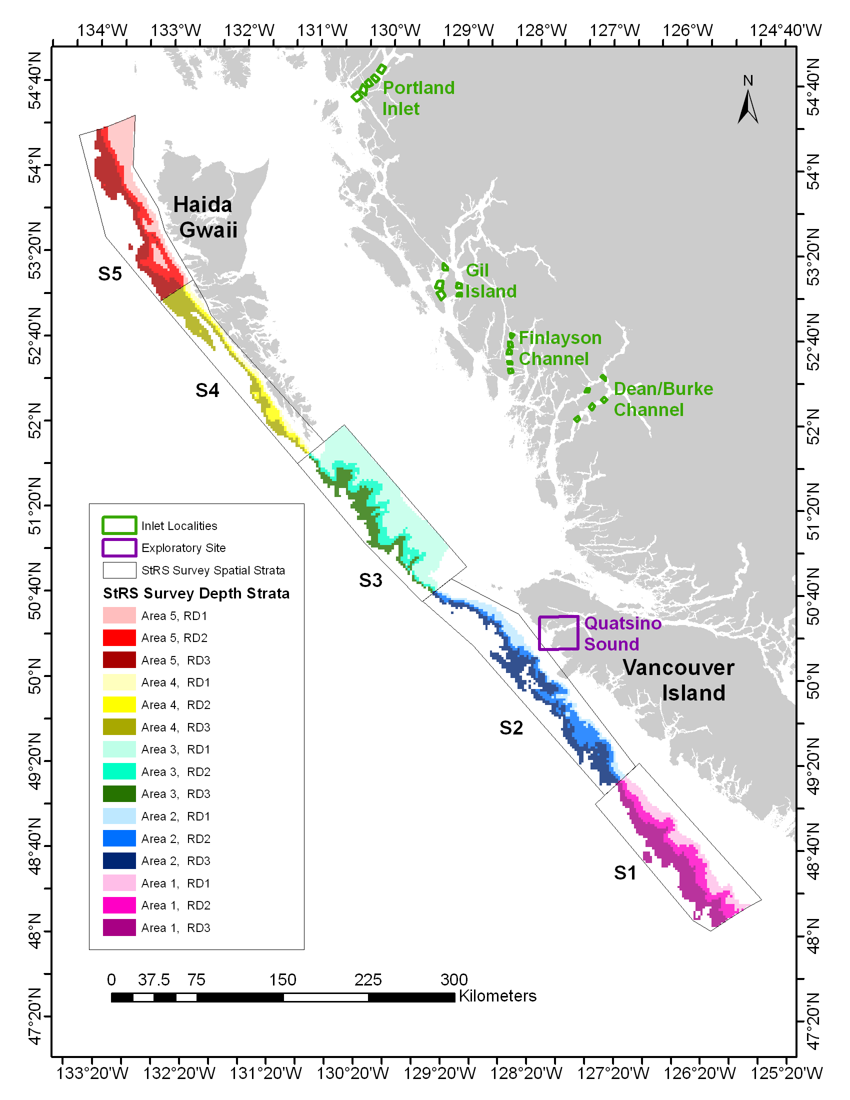

Figure 1. Location of the boundaries of the mainland inlet localities, one exploratory site and the five spatial areas (S1-S5) of the stratified random survey design. The three depth strata (RD1-RD3) are colour-coded, nested within each of the five spatial strata. The inset shows the Groundfish Management Unit (GMU) areas.

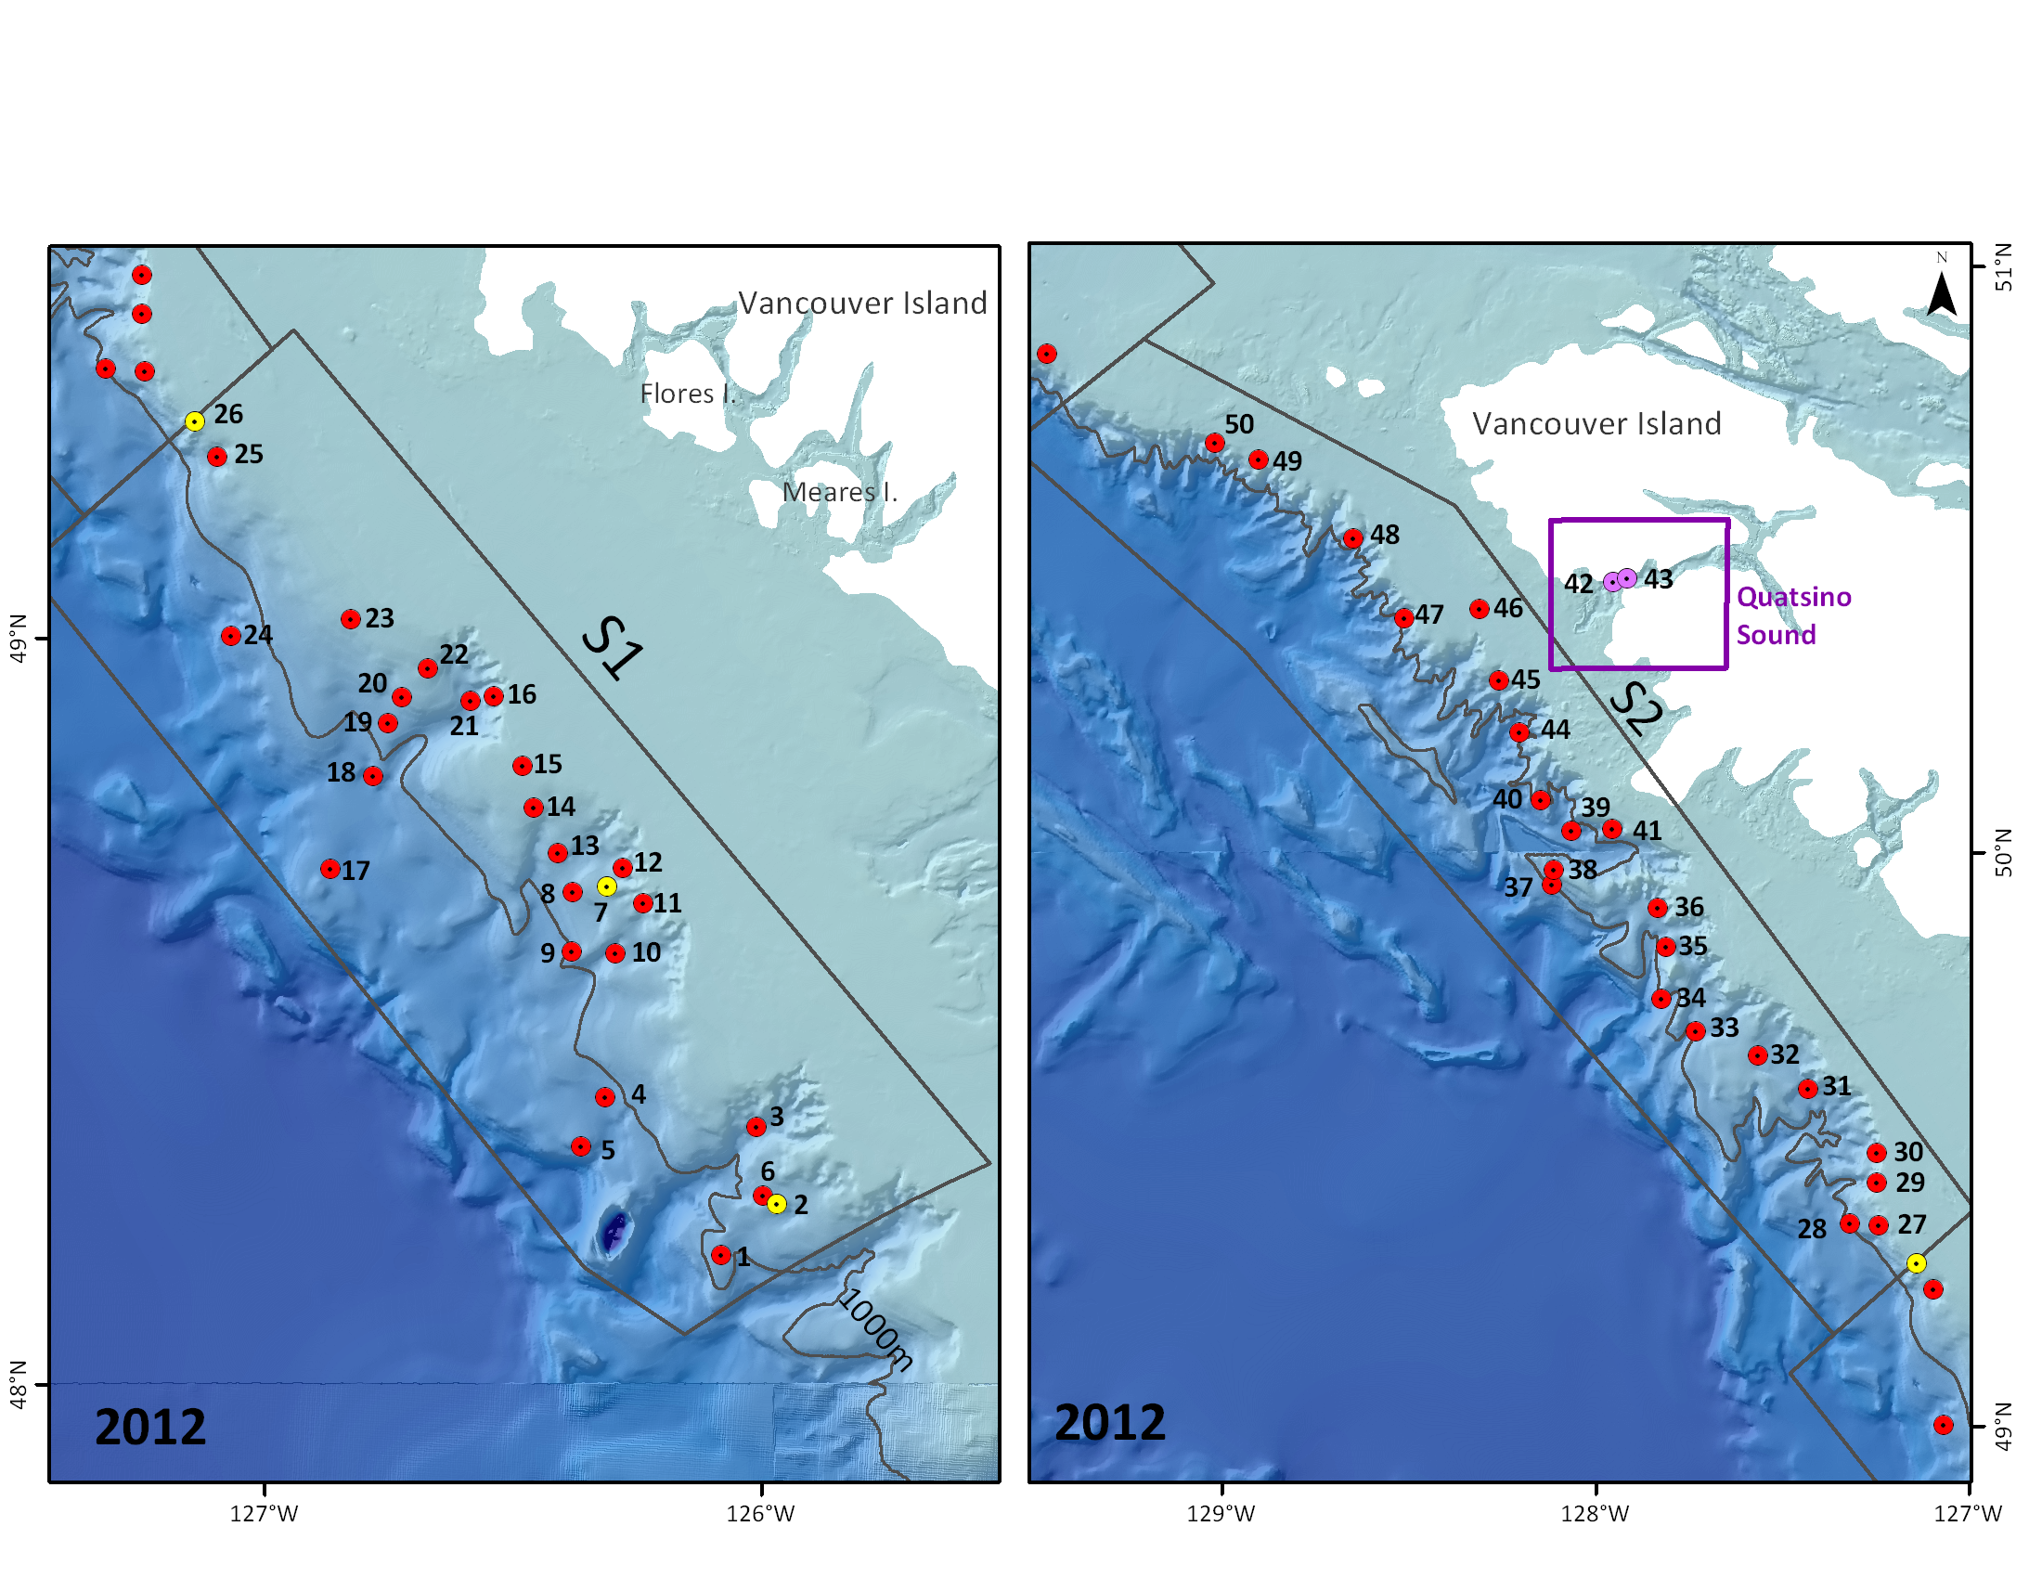

Figure 2. Start locations of the 2012 survey sets (red markers) conducted in the stratified random survey areas S1 and S2 and survey sets conducted (purple markers) in the exploratory area. The camera sets are represented by yellow markers.

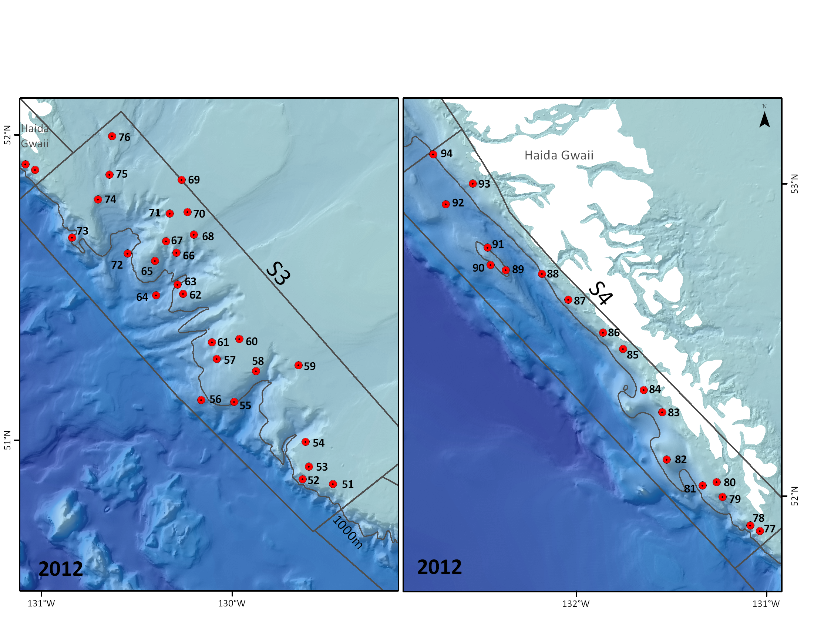

Figure 3. Start locations of the 2012 survey sets (red markers) conducted in the stratified random survey areas S3 and S4.

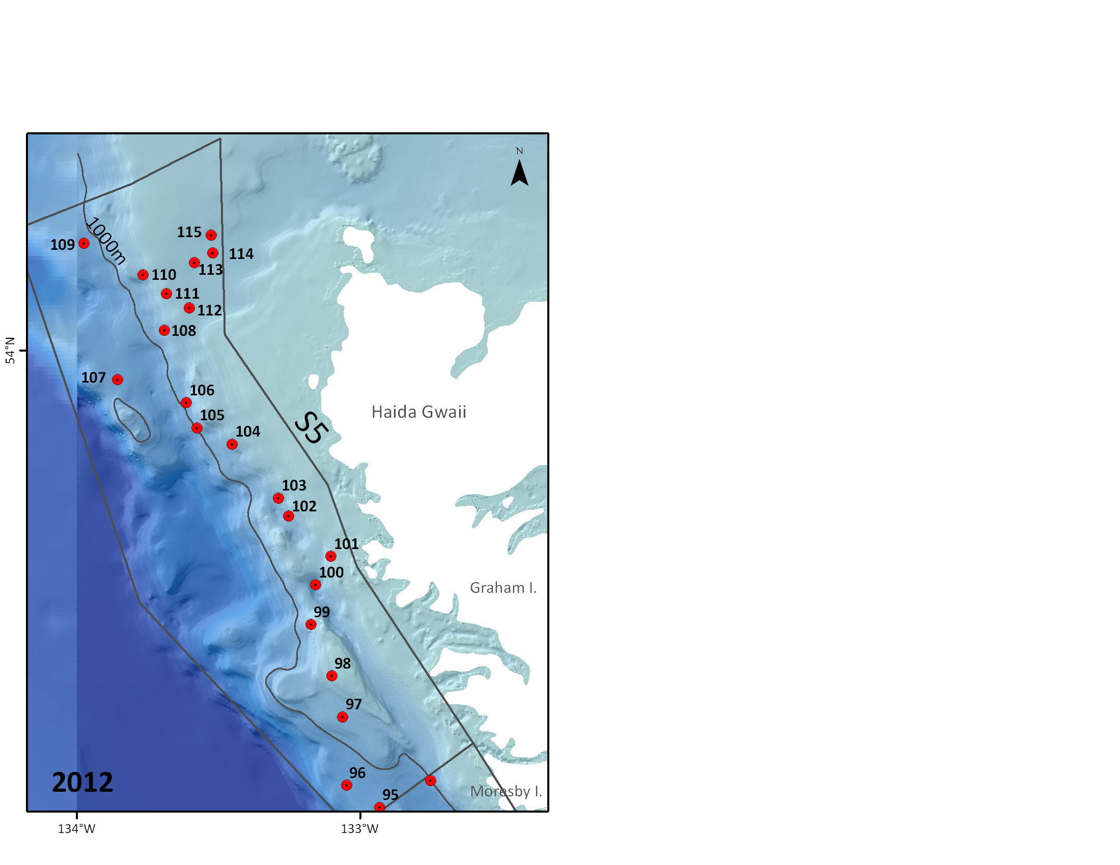

Figure 4. Start locations of the 2012 survey sets (red markers) conducted in the stratified random survey area S5.

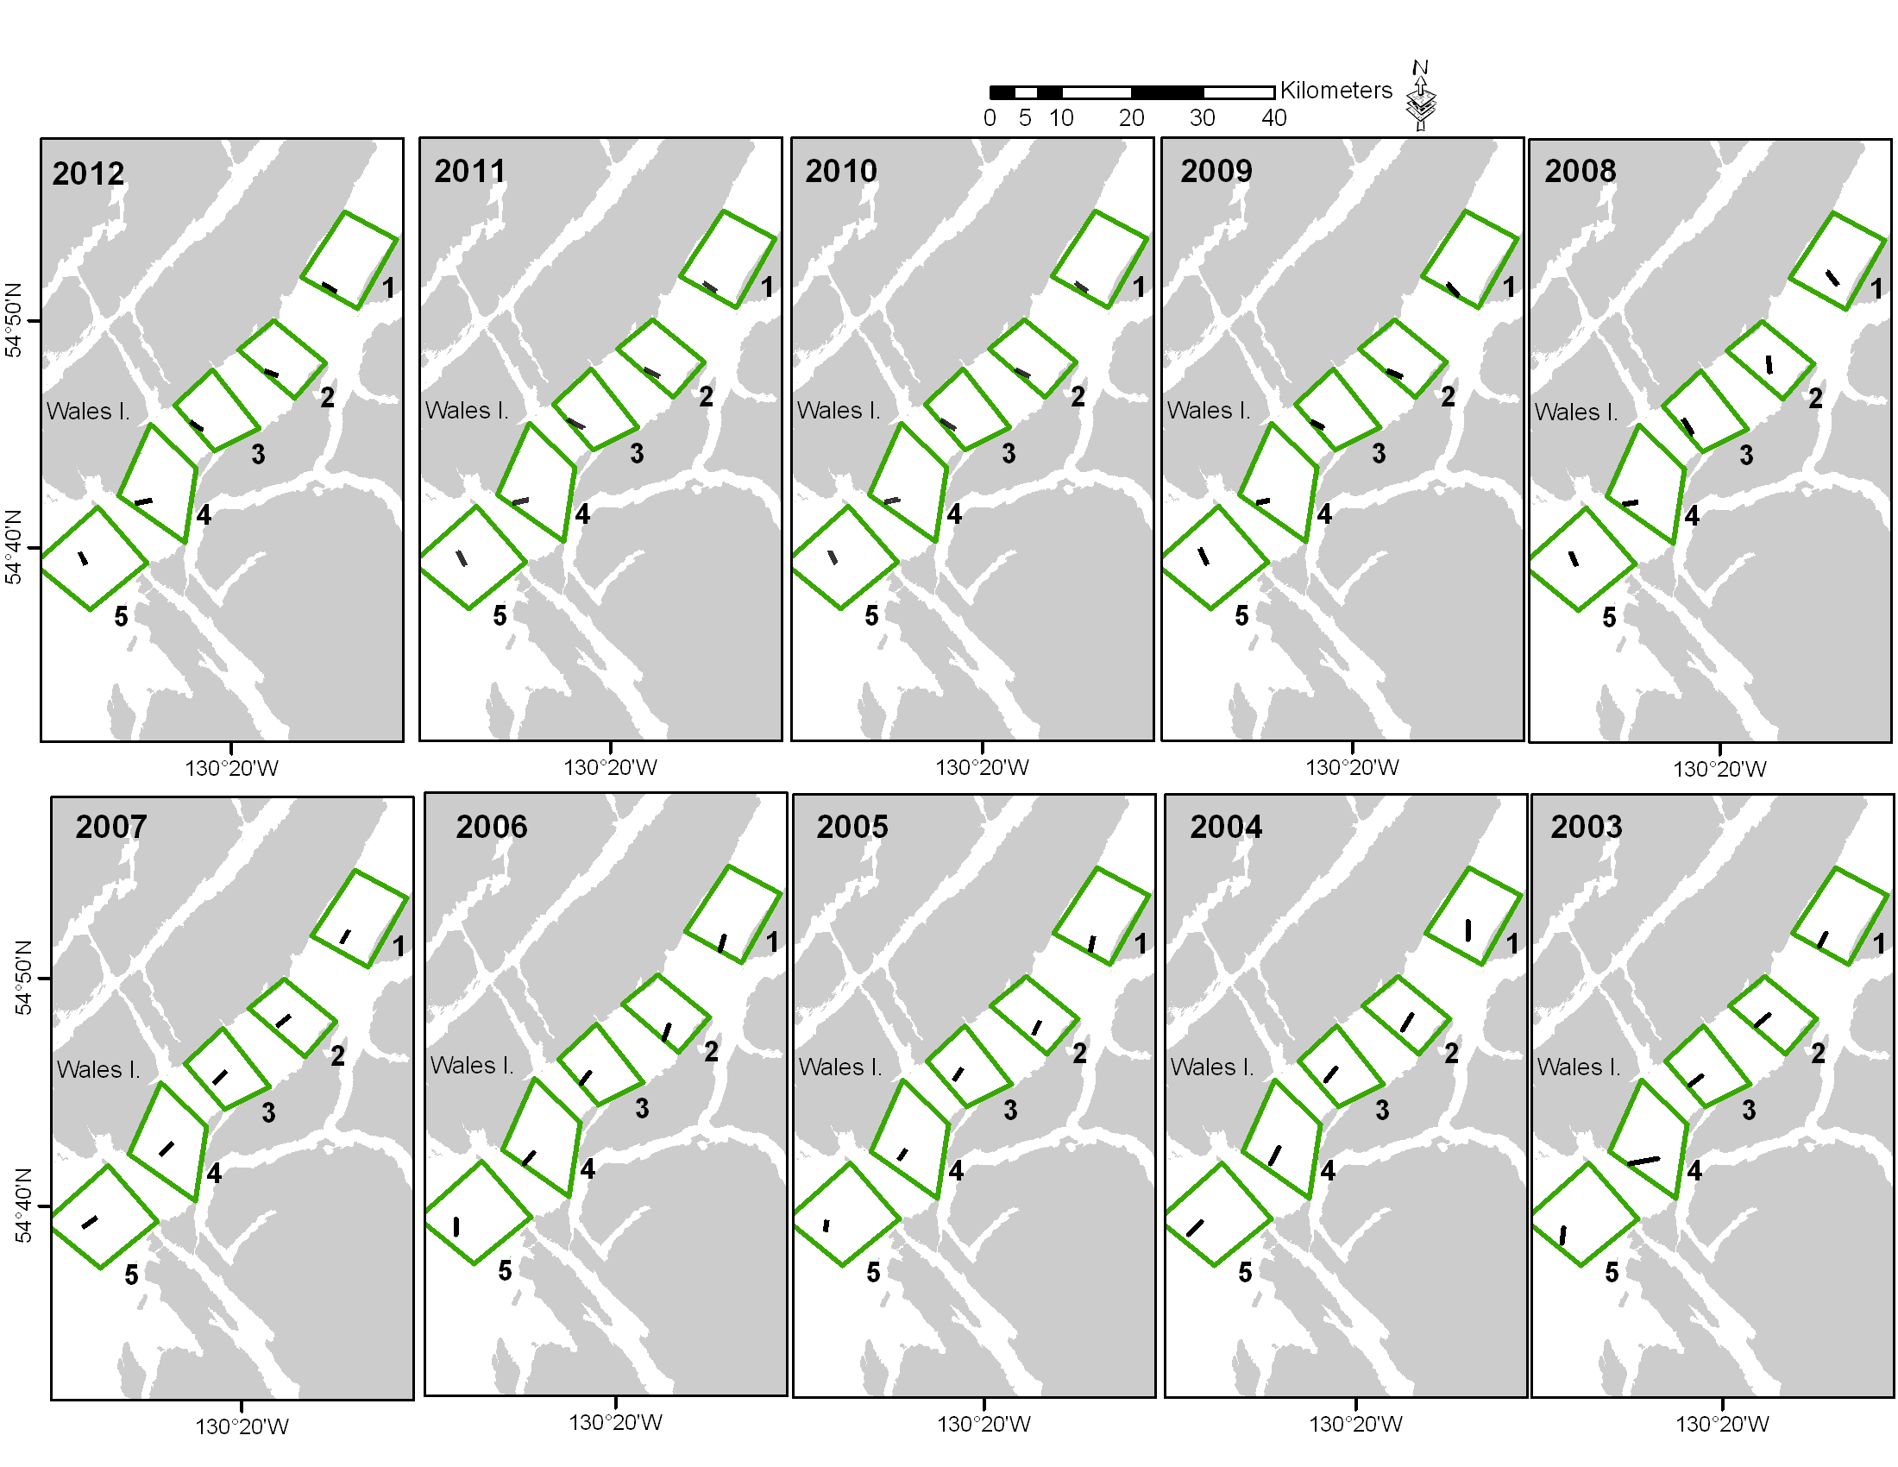

Figure 5. Location of the traditional survey sets at the Portland Inlet mainland locality 2003 through 2012.

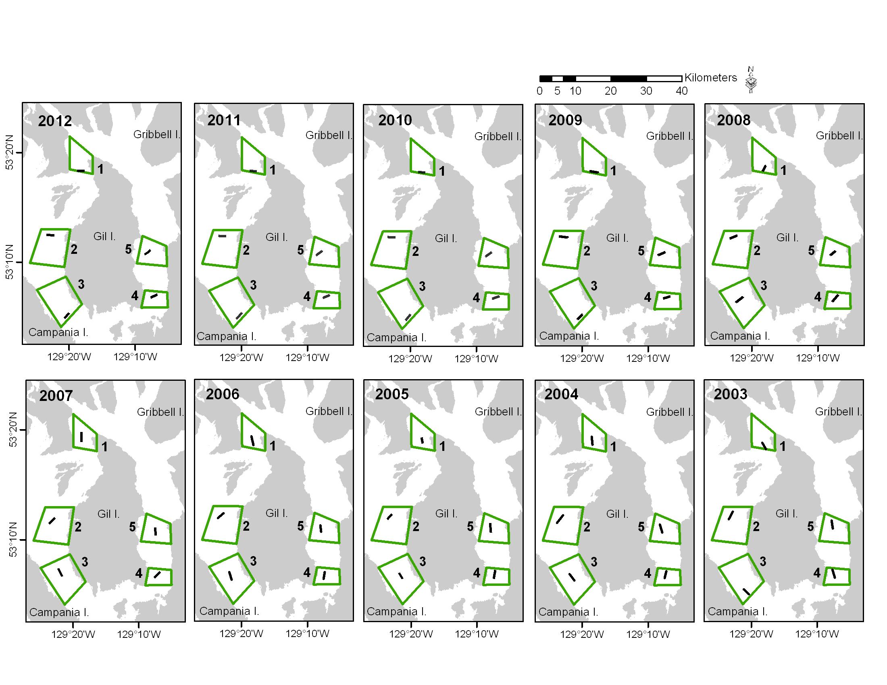

Figure 6. Location of the traditional survey sets at the Gil Island mainland inlet locality 2003 through 2012.

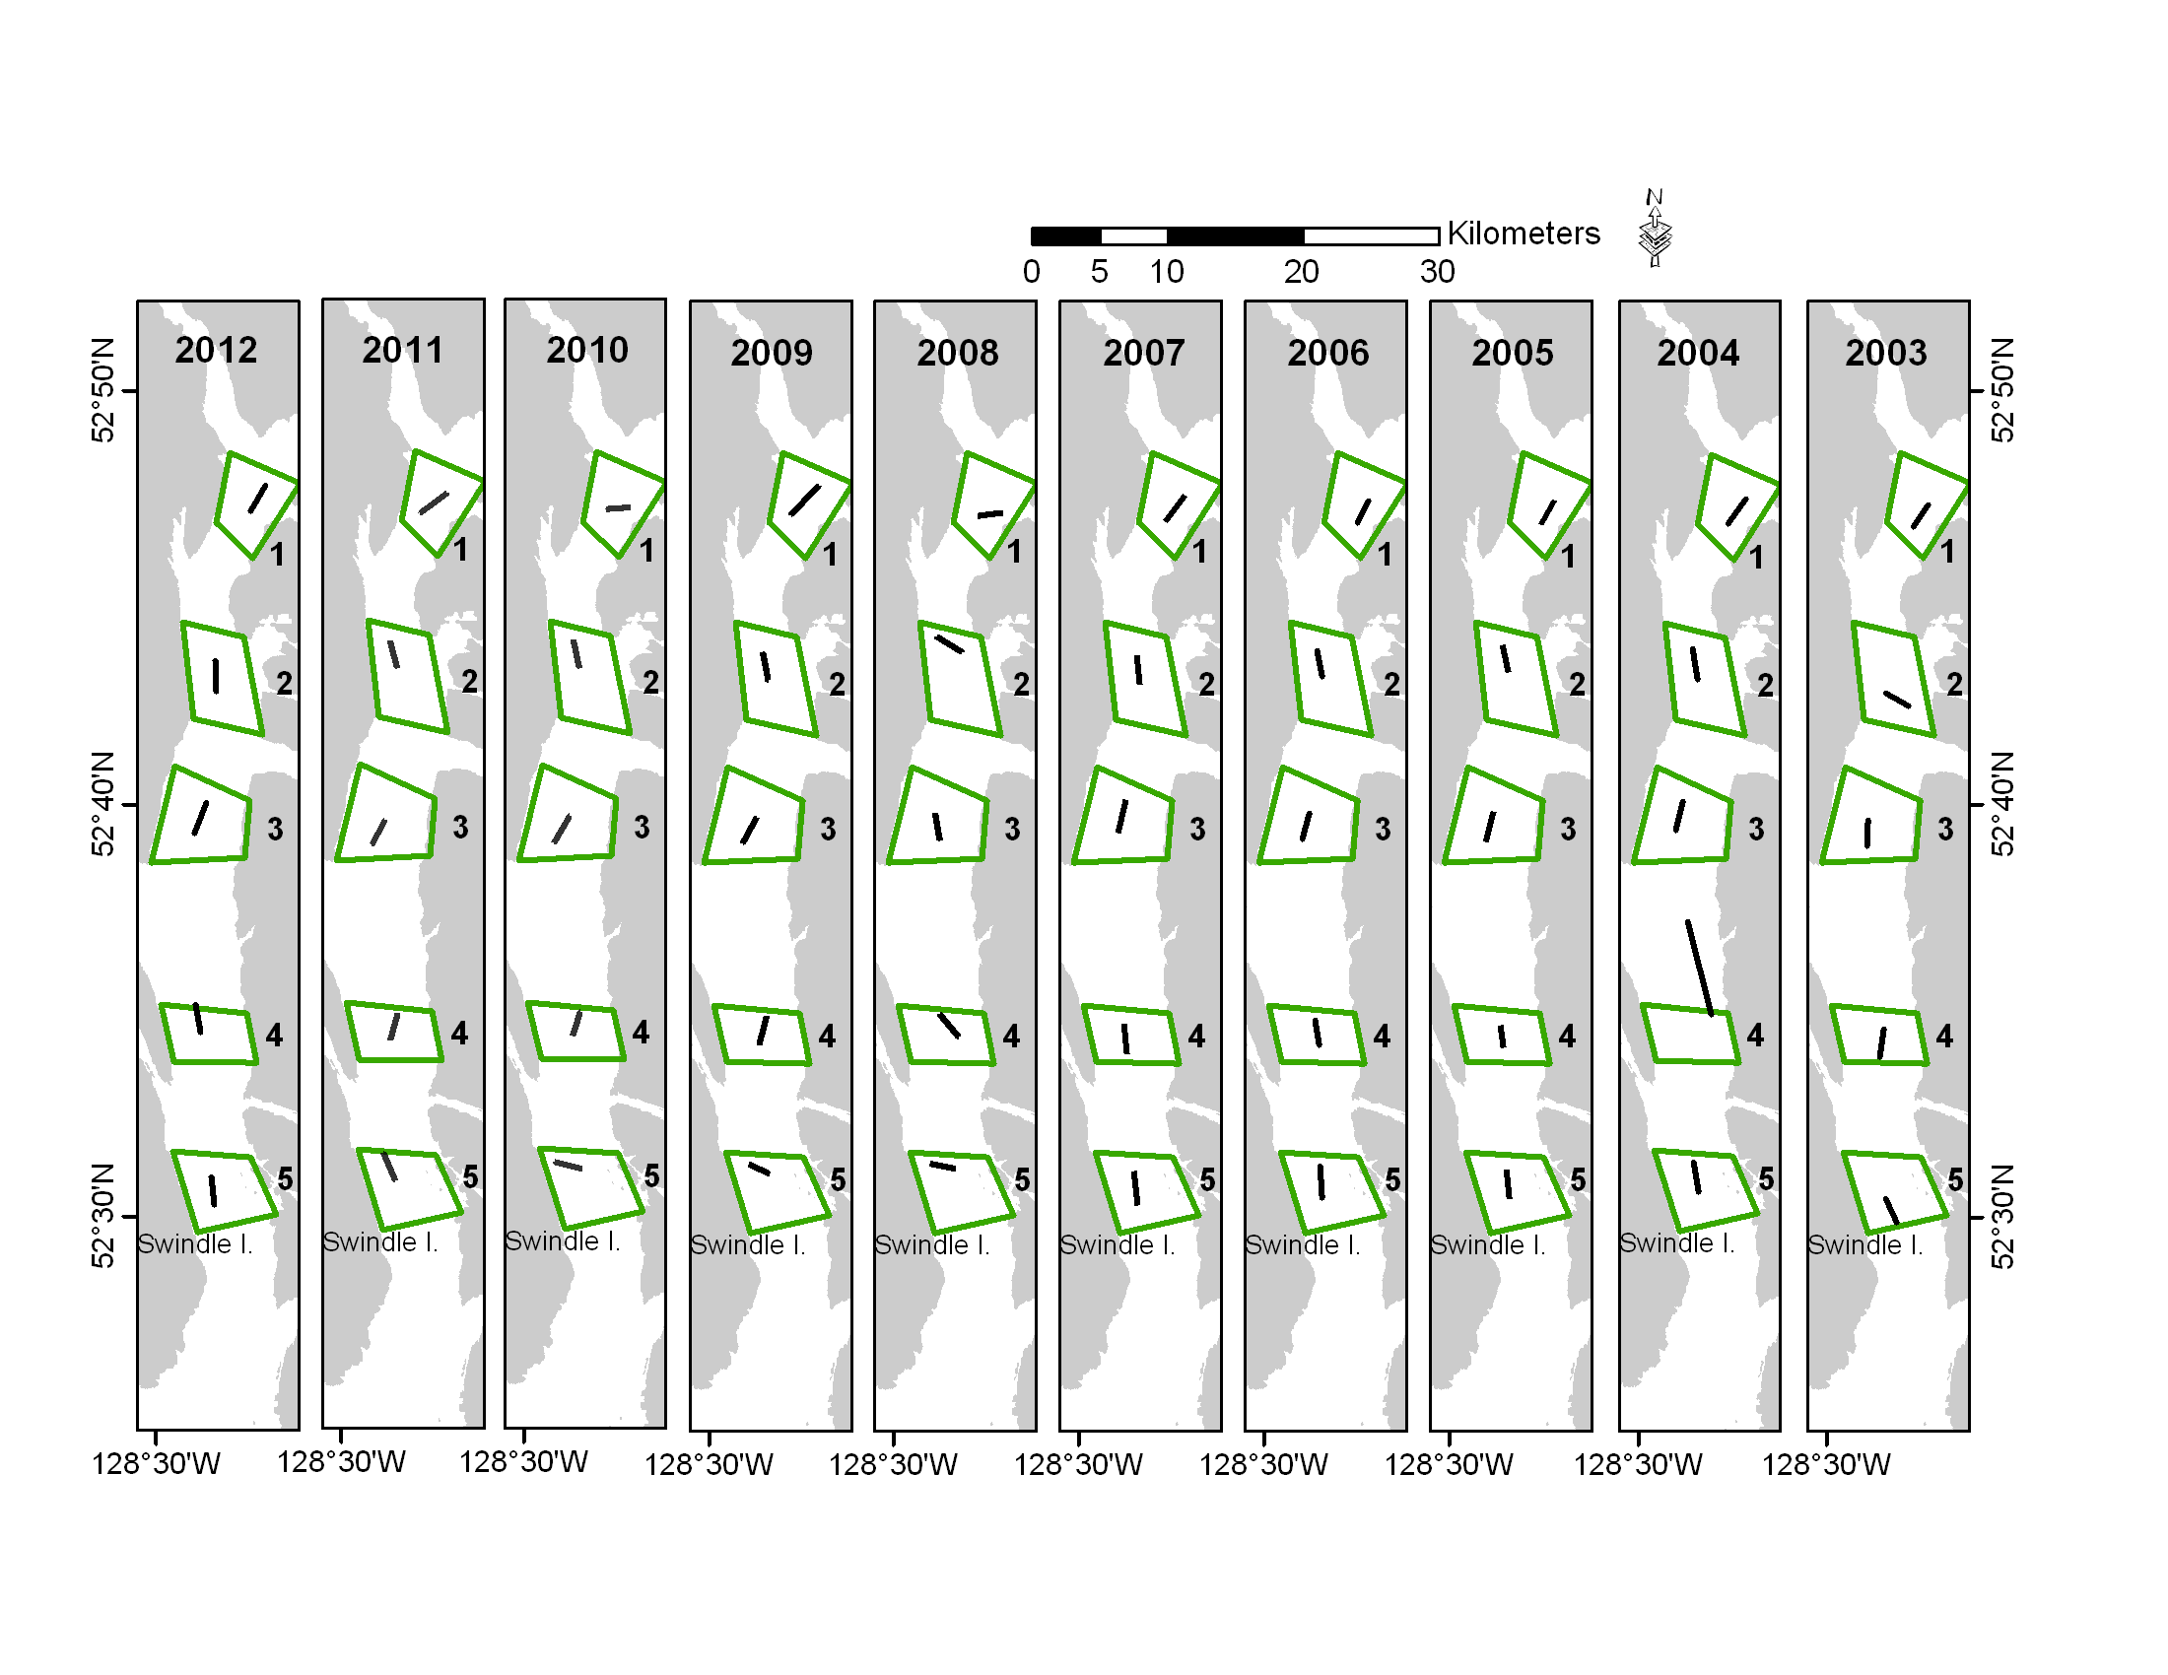

Figure 7. Location of the traditional survey sets at the Finlayson Channel mainland inlet locality 2003 through 2012.

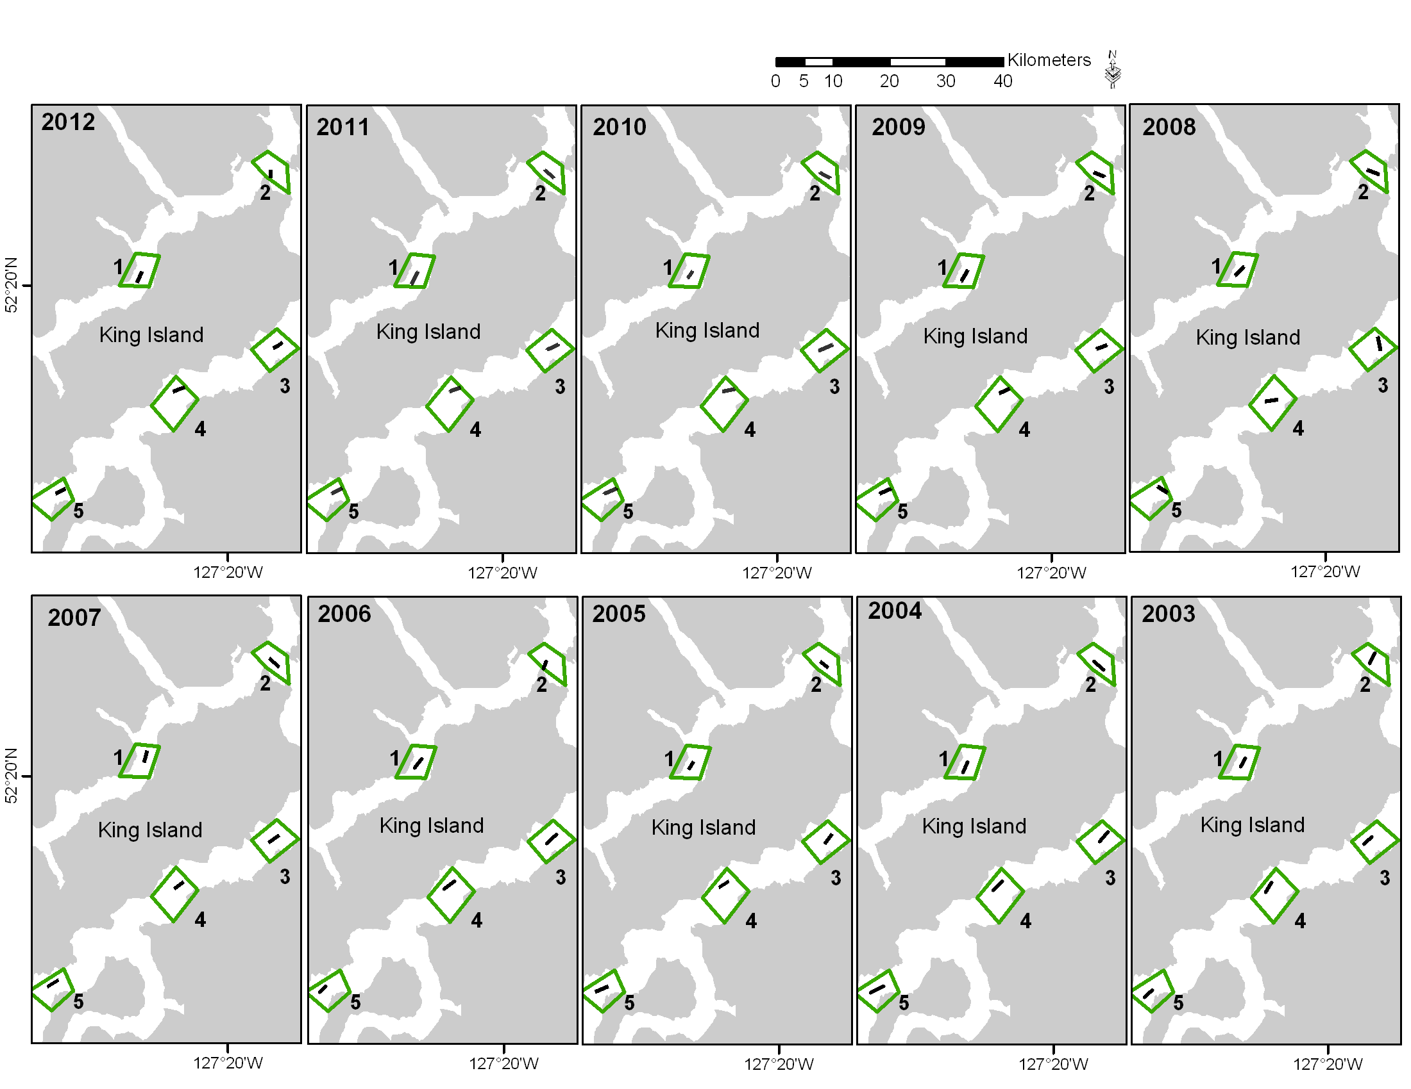

Figure 8. Location of the traditional survey sets at the Dean/Burke Channel mainland inlet locality 2003 through 2012.

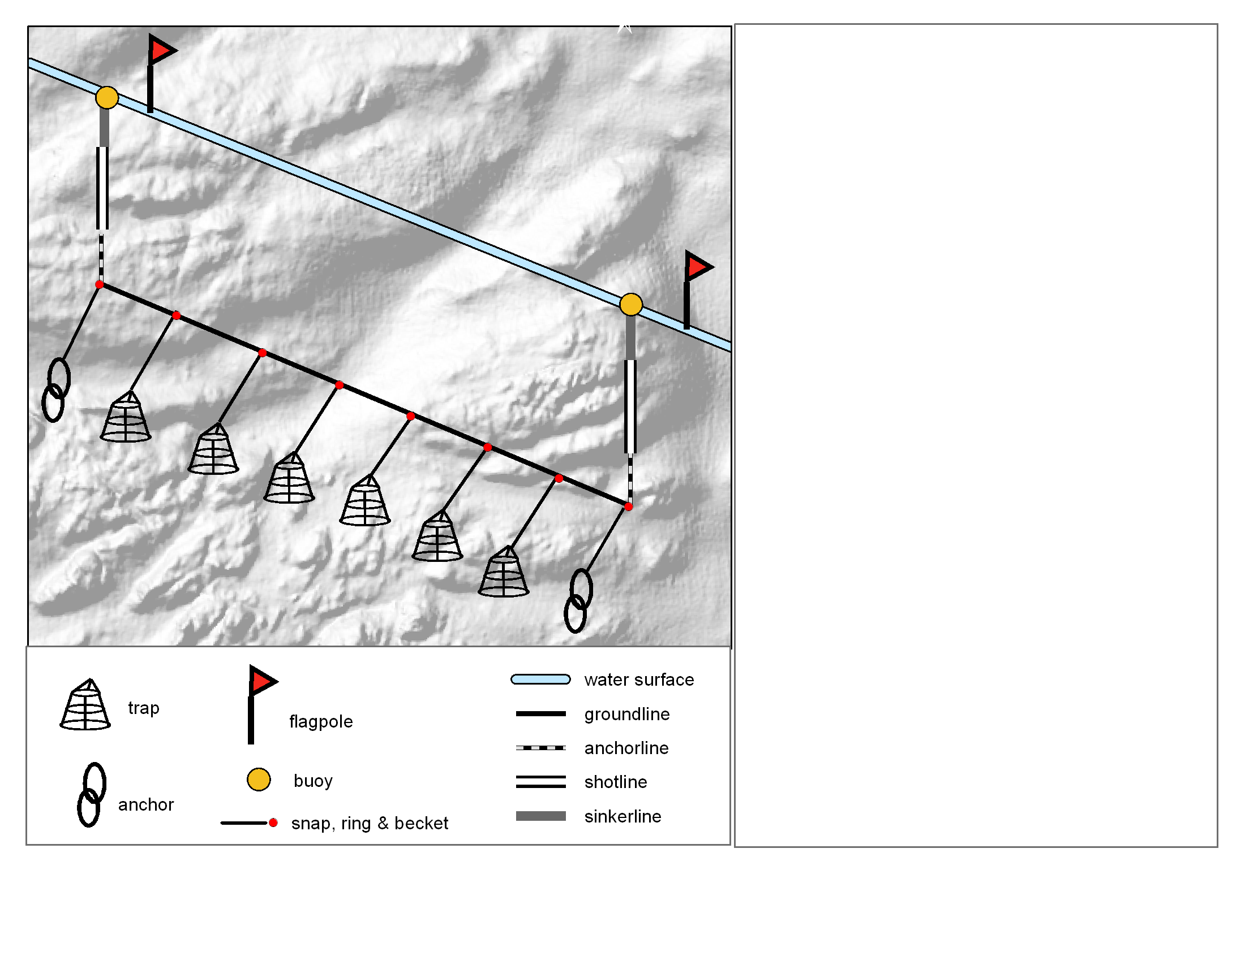

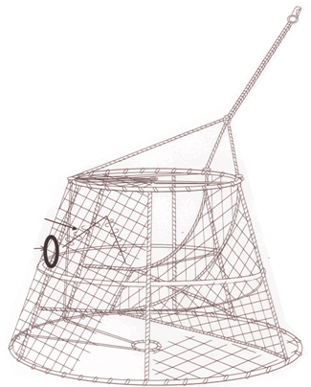

bridle

tunnel

escape

ring

escape

tunnel

framework

Figure 9. Individual components of the survey fishing gear.

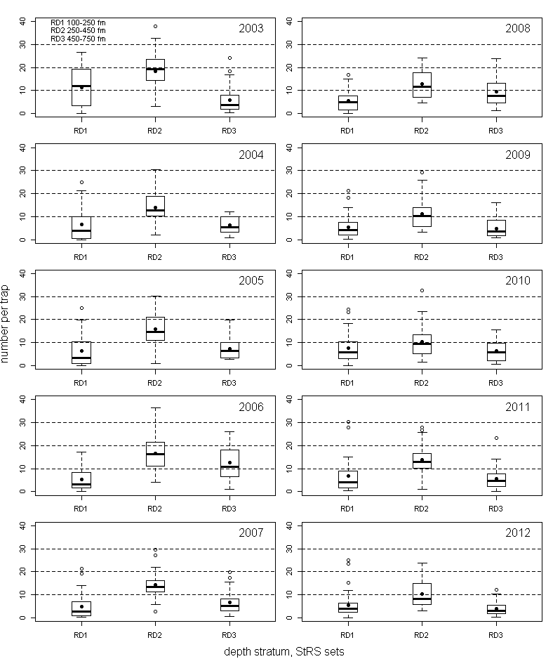

Figure 10. Distribution of catch rates for Type 3 tagging sets summarised by a boxplot for each depth stratum by year (2003-2012). Each panel shows catch rates grouped by depth strata from shallow to deep (RD1-RD3) for each year the StRS survey was conducted. The filled circles show the mean catch rates for each depth stratum.

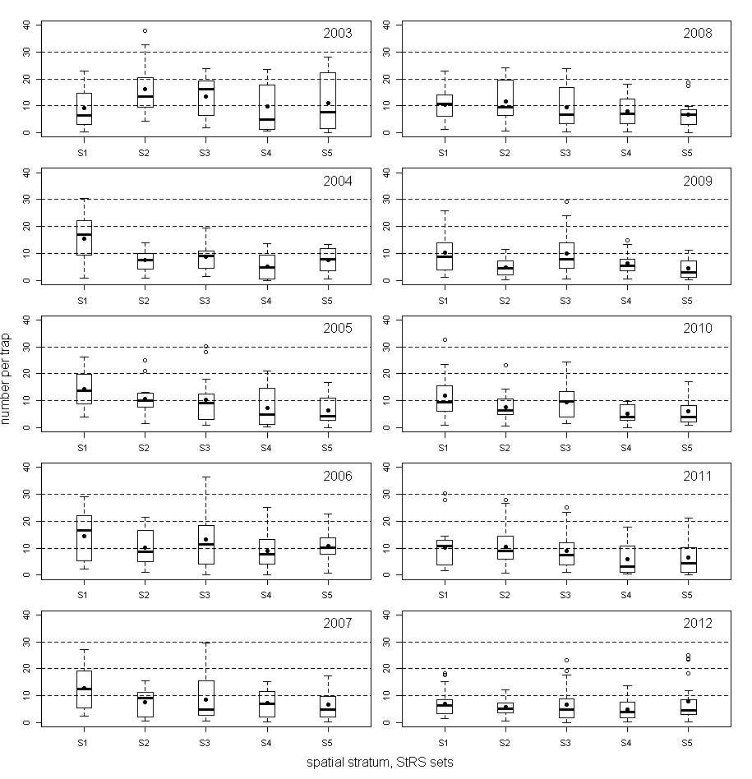

Figure 11. Distribution of catch rates for Type 3 tagging sets summarized by a boxplot for each spatial stratum by year (2003-2012). Each panel shows catch rates grouped by spatial strata from south to north (S1- S5) for each year the StRS survey has taken place. The filled circles show the mean catch rates in each stratum



Figure 12. Graph of mean catch rates by year for StRS design Type 3 tagging sets summarised for each spatial stratum (S1-S5) . The inset shows the location of the five spatial strata.

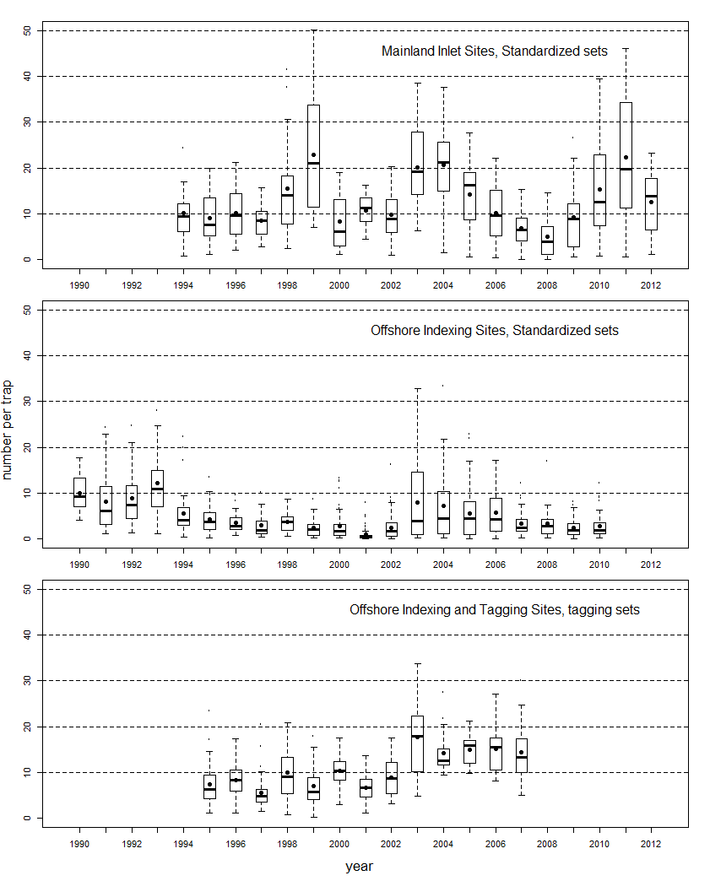

Figure 13. Distribution of catch rates summarised by boxplots for standardized sets conducted at mainland Inlet localities, standardized sets conducted at Offshore

Indexing localities and Type 1 tagging sets conducted at both Offshore Tagging and Indexing localities. The filled circles show the mean catch rates.

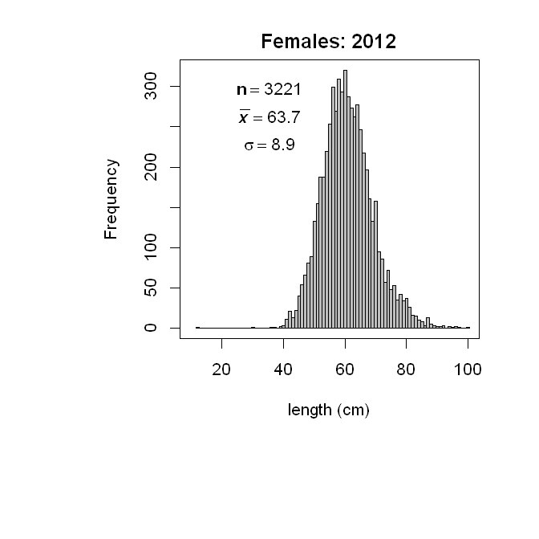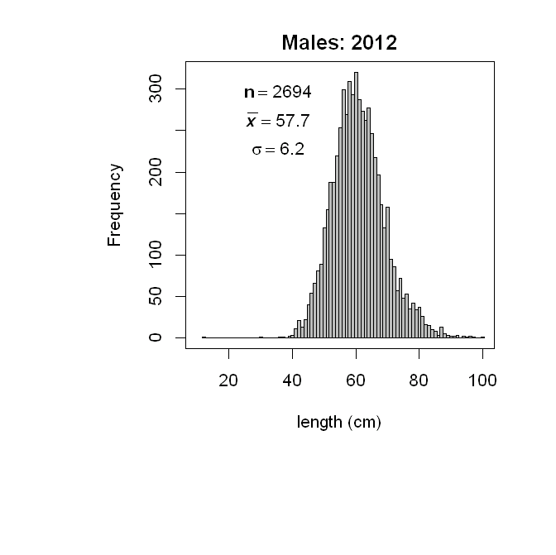

Figure 14. Sablefish length frequency (cm) for males and females for the 2012 survey. The specimen counts are represented by the symbol n, the mean length by the xbar symbol, , and the standard deviation by the symbol σ.

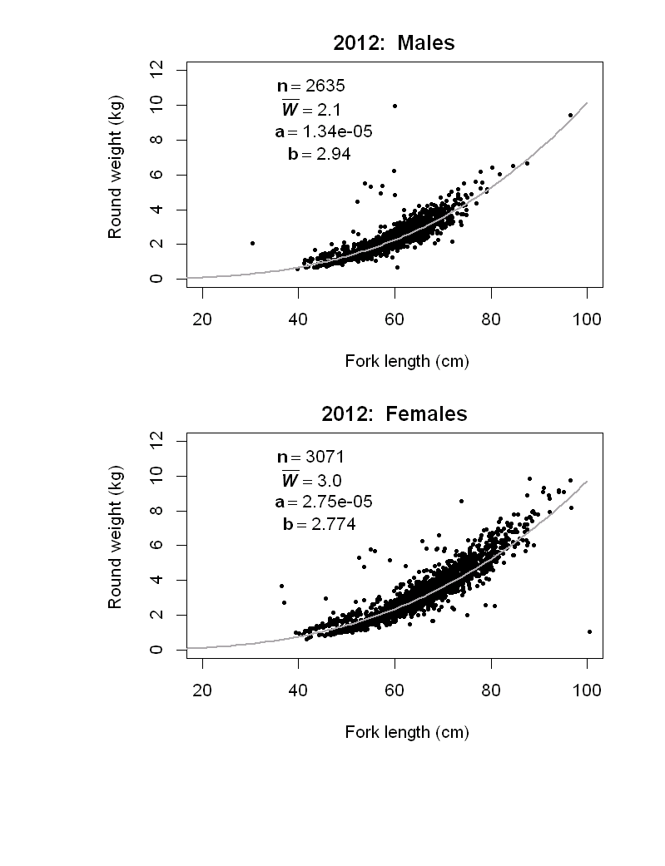

Figure 15. Sablefish fork length (L in cm) vs weight (W in kg) for males and females for the 2012 survey, where W=aLb.

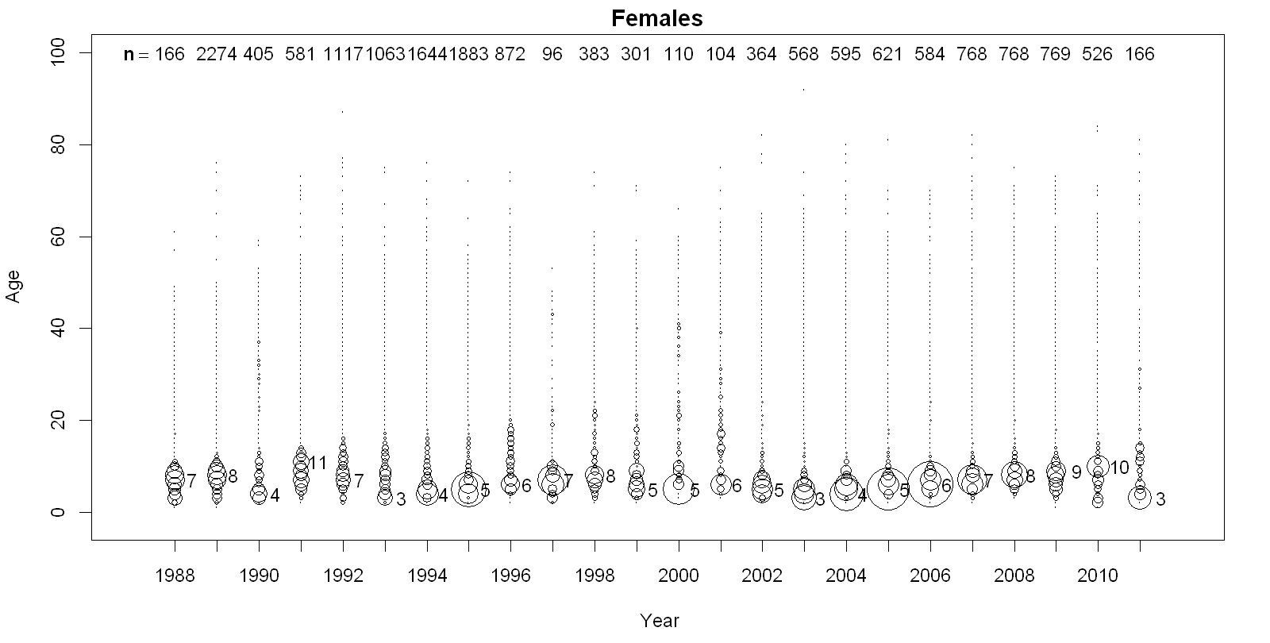

Figure 16. Bubble plot for female Sablefish ages by survey year (1988-2011). The width of the circles are proportional to the number of aged fish. For each year, the age with the highest proportion is listed to the right. The number (n) of fish aged at the time of this report are stated at the top of the panel.

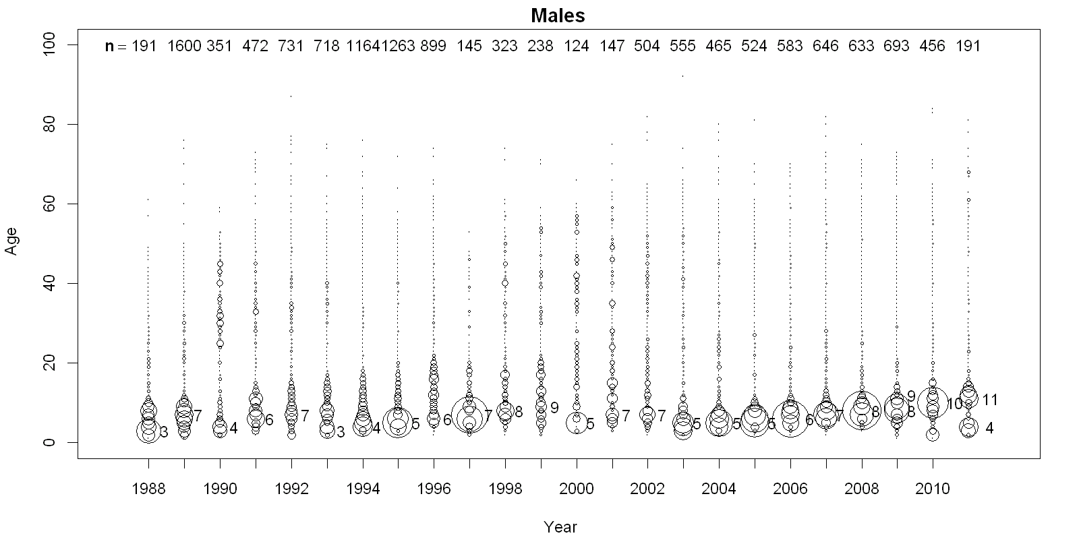

Figure 17. Bubble plot for male Sablefish ages by survey year (1988-2011). The width of the circles are proportional to the number of aged fish. For each year, the age with the highest proportion is listed to the right. The number (n) of fish aged at the time of this report are stated at the top of the panel.

Latitude: 48 º- 49º 49º - 50º 50º - 51º 51º - 52º 52º - 53º 53º - 54º 54º - 55º

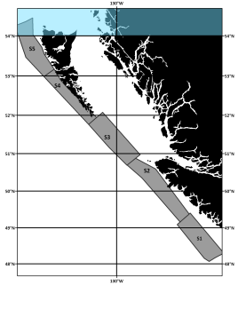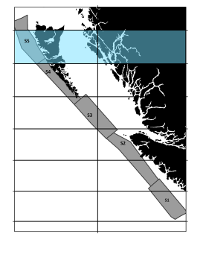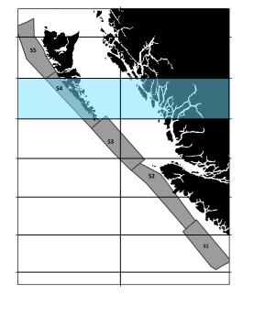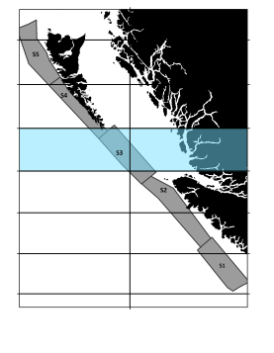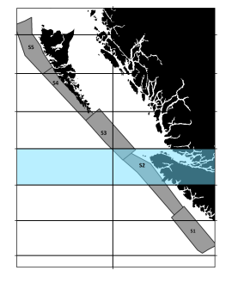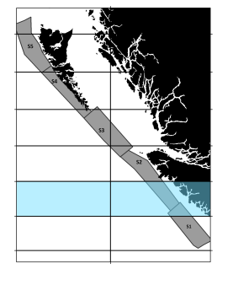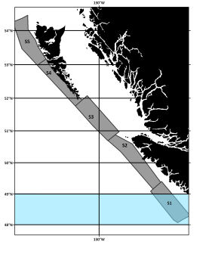

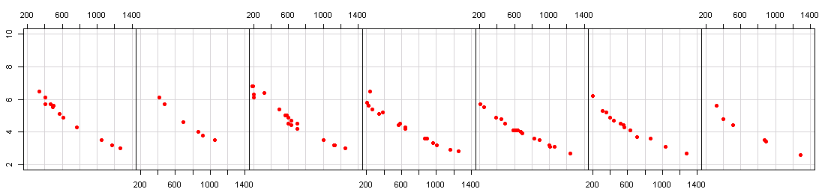

n=6

n=18

n=16

n=17

n=13

n=13

n=6

2007

2007

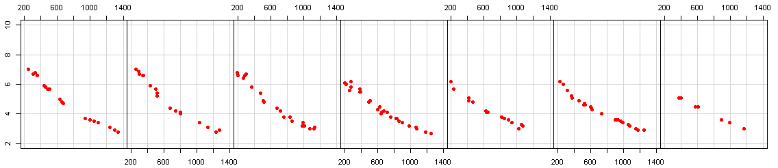

2008

n=13

n=14

n=27

n=13

n=24

n=19

n=8

Average temperature (ºC)

Average depth (m)

Figure 18. Coplot of average depth(m) vs average temperature (ºC) for a given 1-degree latitude intervals (blue bands) for 2007 and 2008. The number of fishing sets deployed with a SBE 39 recorder are represented by n.

Latitude: 48 º- 49º 49º - 50º 50º - 51º 51º - 52º 52º - 53º 53º - 54º 54º - 55º

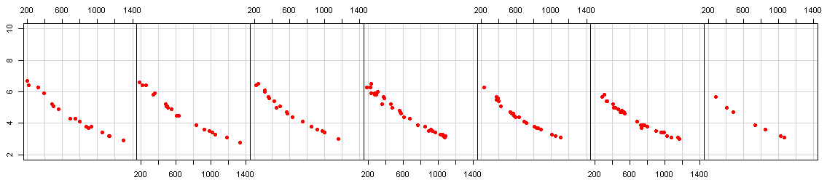

2010

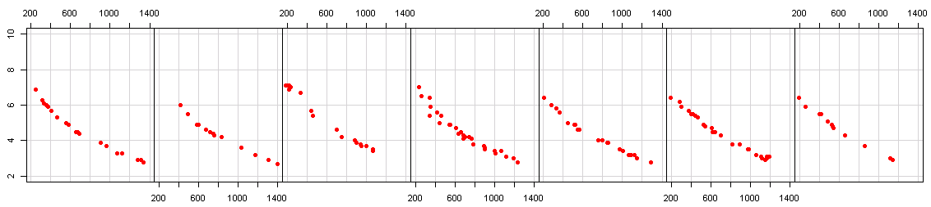

2009

n=13

n=17

n=29

n=20

n=21

n=21

n=10

Average temperature (ºC)

n=20

n=15

n=26

n=21

n=24

n=14

n=6

Average depth (m)

Figure 19. Coplot of average depth(m) vs average temperature (ºC) for a given 1-degree latitude range (blue bands) for 2009 and 2010. The number of fishing sets deployed with a SBE 39 recorder are represented by n.

Latitude: 48 º- 49º 49º - 50º 50º - 51º 51º - 52º 52º - 53º 53º - 54º 54º - 55º

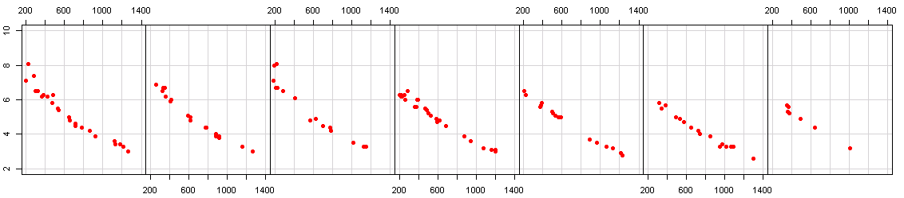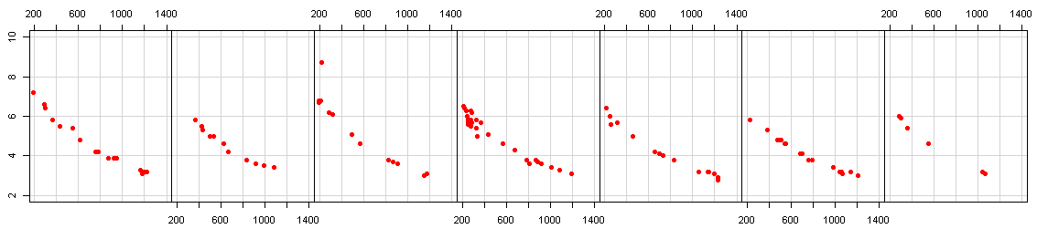

2011

2012

2

n=10

n=12

n=24

n=13

n=15

n=16

n=5

Average temperature (ºC)

n=16

n=15

n=24

n=13

n=15

n=22

n=7

Average depth (m)

Figure 20. Coplot of average depth(m) vs average temperature (ºC) for a given 1-degree latitude range (blue bands) for 2011 and 2012. The number of fishing sets deployed with a SBE 39 recorder are represented by n.

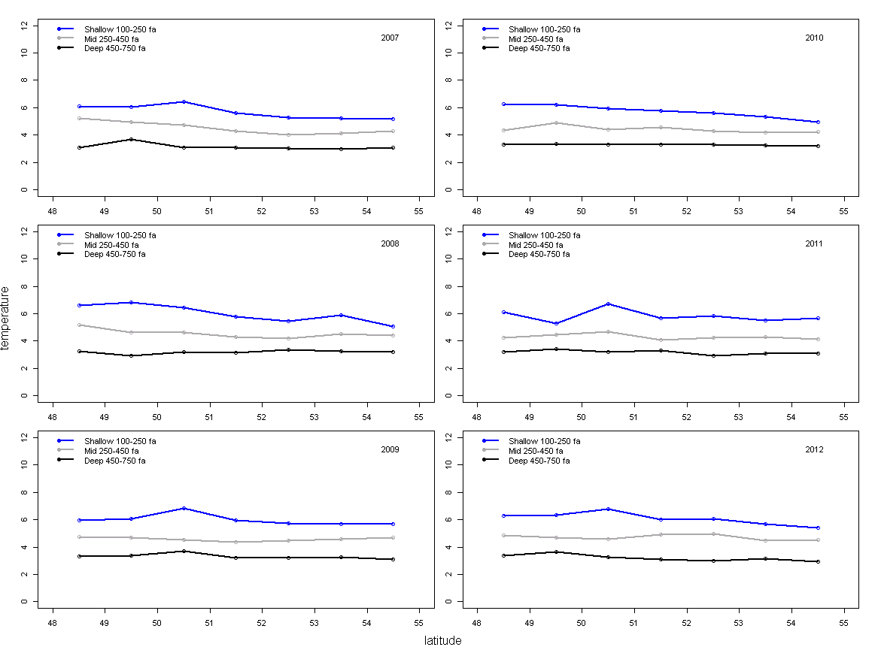

Figure 21. Average temperatures as reported from the Sea-bird SBE 39 loggers at 1-degree latitude intervals and three depth intervals: 100-250 fathoms (183 to 457 meters), 250-450 fathoms (458-823 meters) and 450-750 fathoms (824-1372 meters).

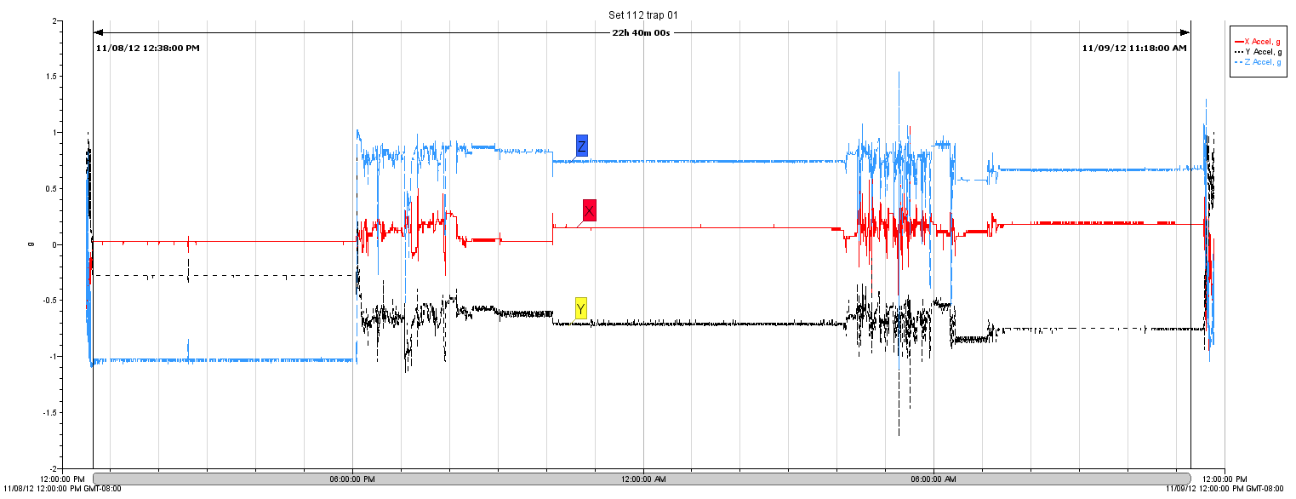

a.

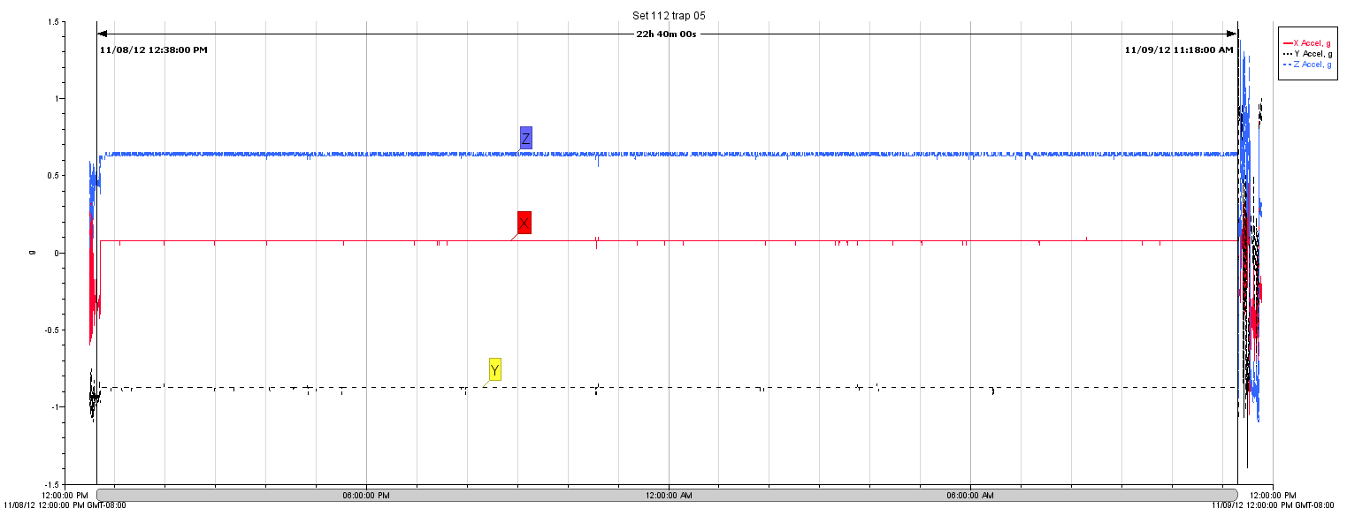

b.

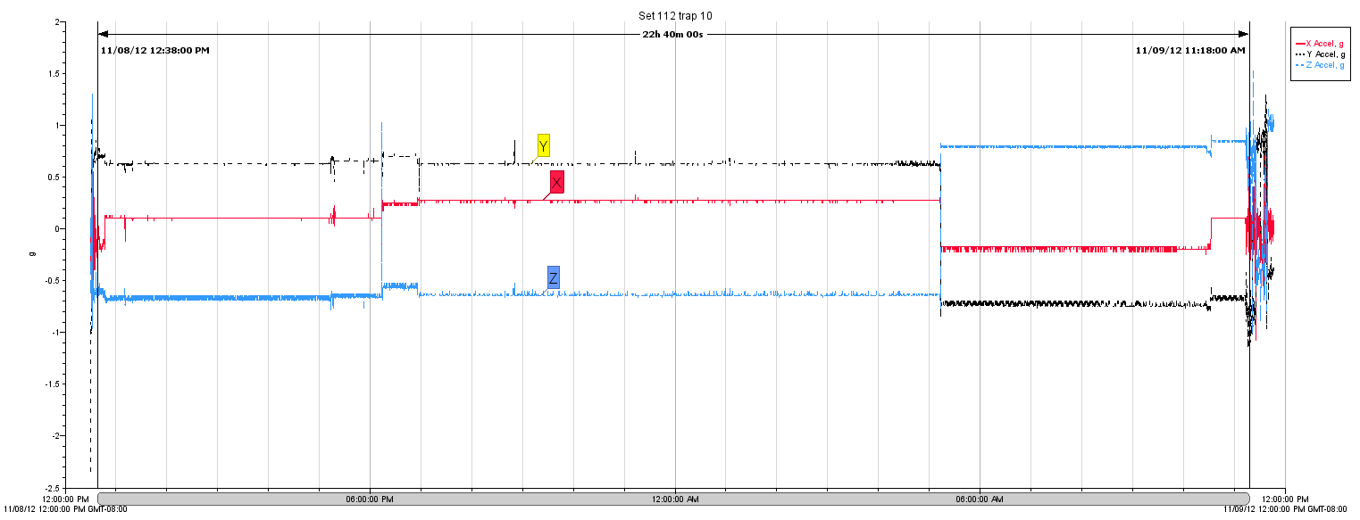

c.

Figure 22. Accelerometer graphs of g-force (m/s2) over time for bottom sensors in trap 1 (a.), 5(b.), 10(c.), 15(d.), 20(e.) and 25(f). The arrows on each graph mark the time of the last anchor being set over the stern and the first anchor hauled aboard.

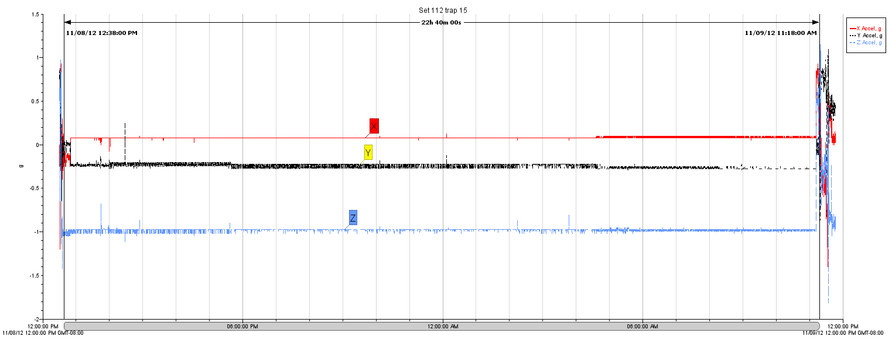

d.

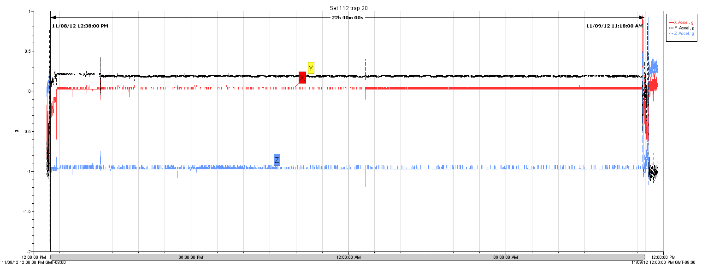

e.

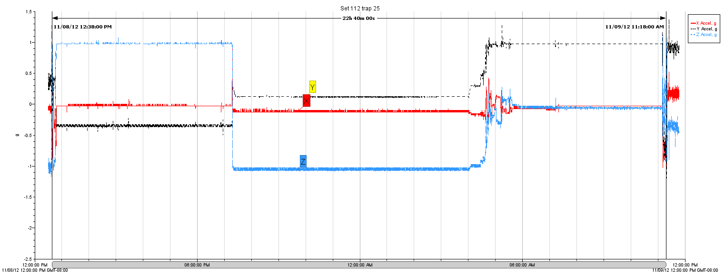

f.

Figure 22. Continued. . Accelerometer graphs of g-force (m/s2) over time for bottom sensors in trap 1 (a.), 5(b.), 10(c.), 15(d.), 20(e.) and 25(f). The arrows on each graph mark the time of the last anchor being set over the stern and the first anchor hauled aboard.

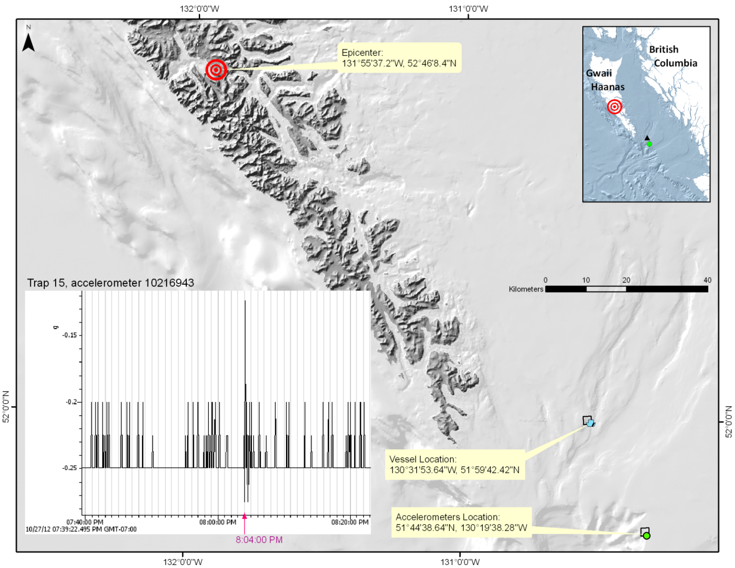

Figure 23. Location of the epicentre of a 7.7 magnitude earthquake on Saturday October 27, 2012 at 8:04 p.m. The inset shows the accelerometer reading that captured the earthquake event.

Appendix A. Details of sets completed during charter 1 of the 2012 survey program (F/V Ocean Pearl).

Sets are listed by locality/stratum name, set type, depth stratum, start date, end of gear deployment time and duration in minutes. The depth strata for type 3 tagging sets include RD1 (100-250 fathoms), RD2 (250-450 fathoms) and RD3 (450-750 fathoms). The position data includes the major area along with the start and end latitude and longitude in degrees decimal minutes. The bottom depths (in meters) of the fishing set are shown with the mean bottom depth calculated from recordings at one minute intervals between the start and end of the set. The number of traps fished for each set excludes open traps, while holed or fouled traps have been included. Sets that successfully deployed a Seabird SBE temperature and pressure recorder and a Hobo accelerometer are indicated with an ‘x’.



Appendix A. Continued.



Appendix A. Continued.



Appendix A. Continued.



Appendix A. Continued.



Appendix A. Continued.



Appendix B. Diagram of the F/V Ocean Pearl deck and survey activities.

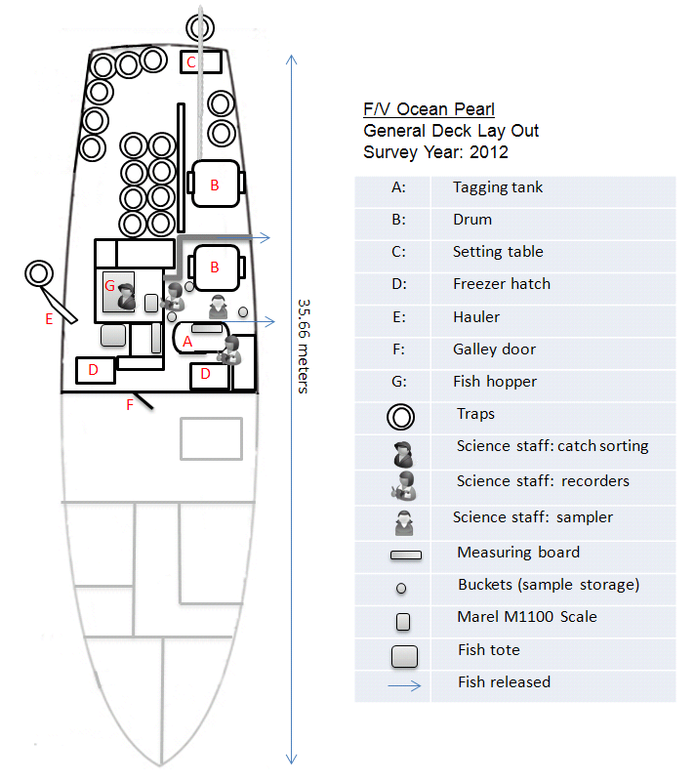

** Not to scale

Appendix C. Example data forms used during the 2012 Sablefish survey.

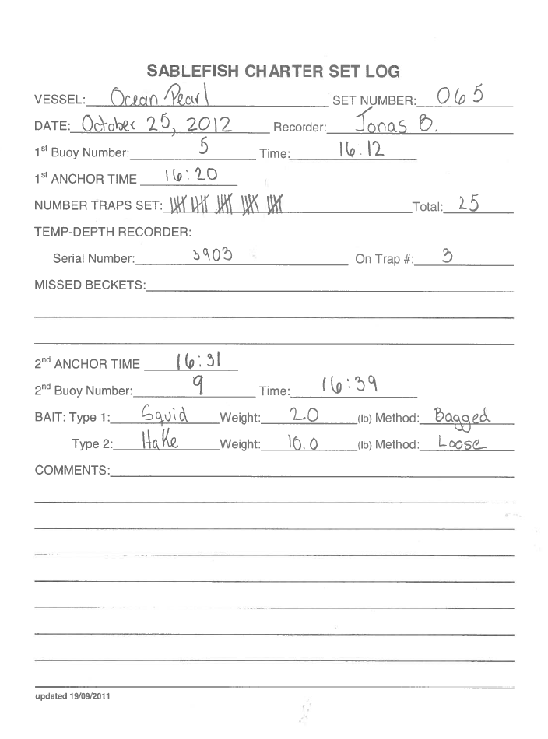

Figure C. 1. Example of a completed set log data form of the type used during the 2012 survey. This from was completed by science staff from the deck as the gear was set.

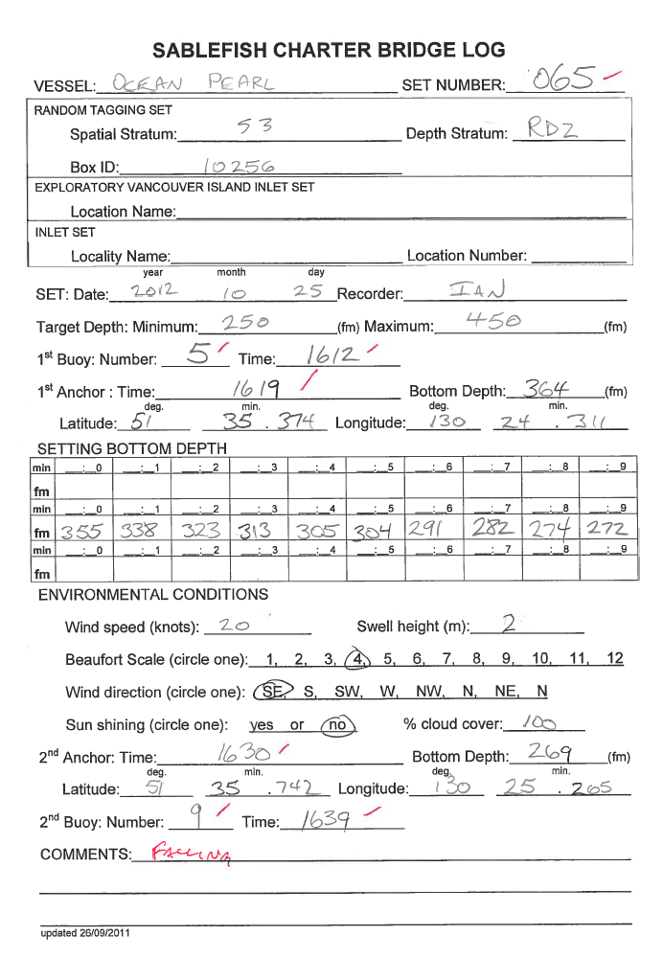

Figure C. 2. Example of a completed bridge log data form used during the 2012 survey. This form was completed from the bridge of the Ocean Pearl for each set.

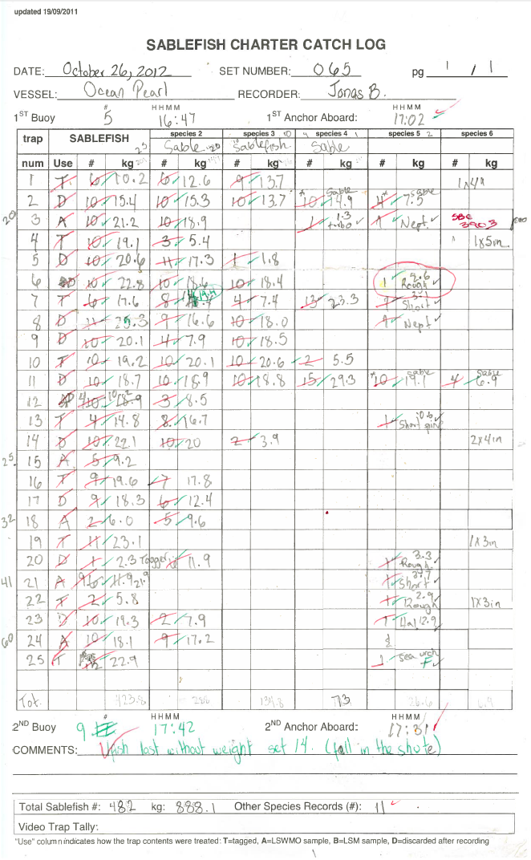

Figure C. 3. Example of a completed catch log data form of the type used during the 2012 survey.

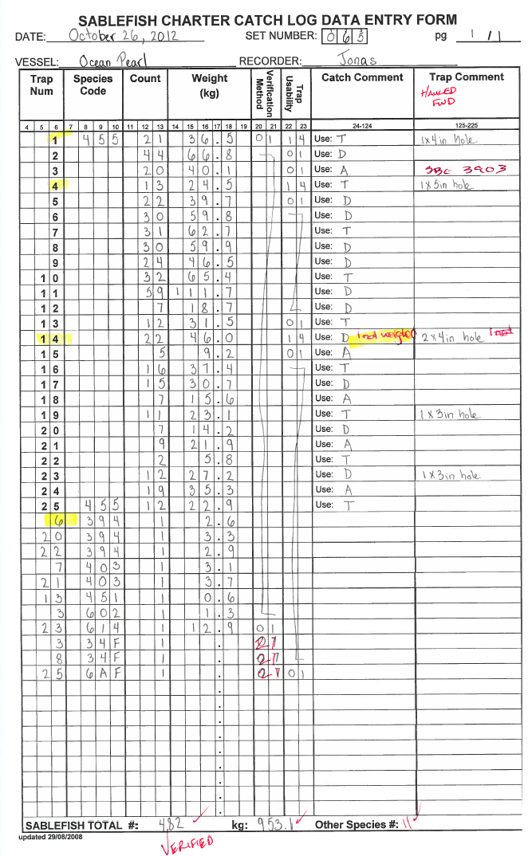

Figure C. . Example of a tabular catch log data entry form transposed from the catch log in Figure C.3.

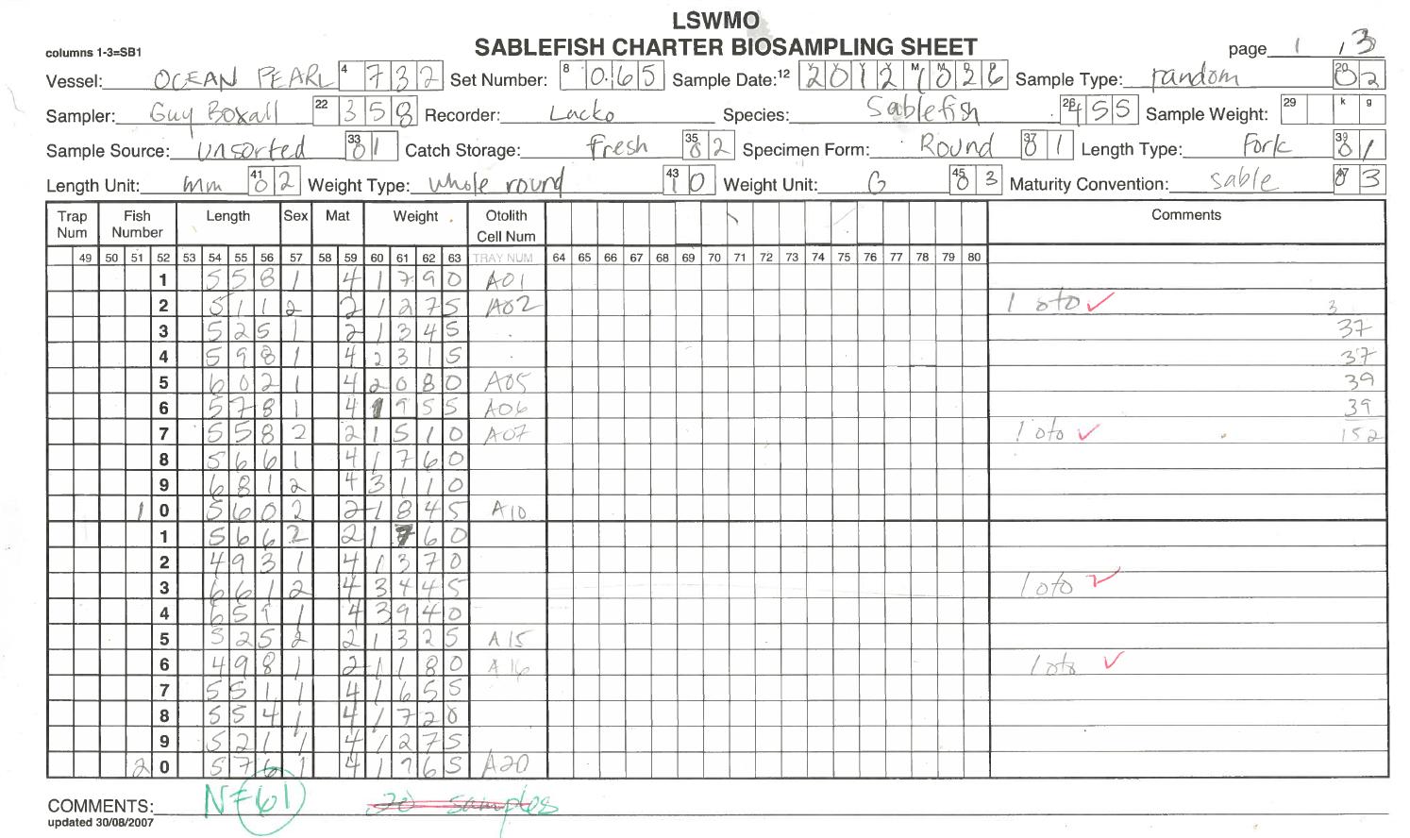

Figure C. . Example of a completed Sablefish biological sampling form of the type used during the 2012 survey for LSWMO samples.

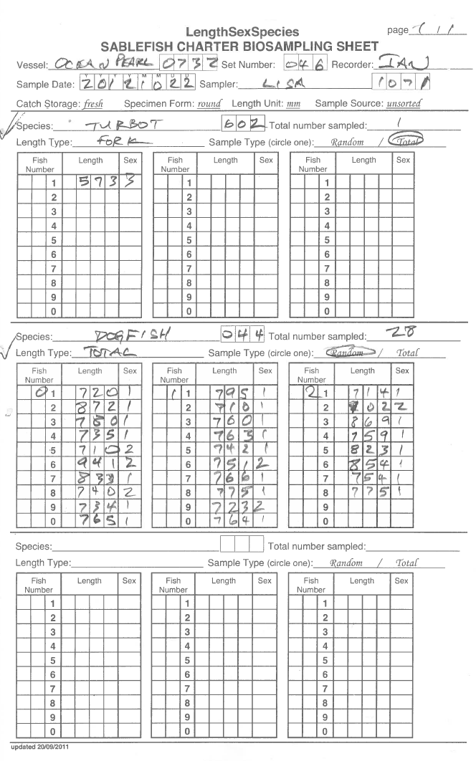

Figure C. 6. Example of a completed LSS biological sampling form of the type used during the 2012 survey for samples of species other than Sablefish or Rougheye Rockfish.

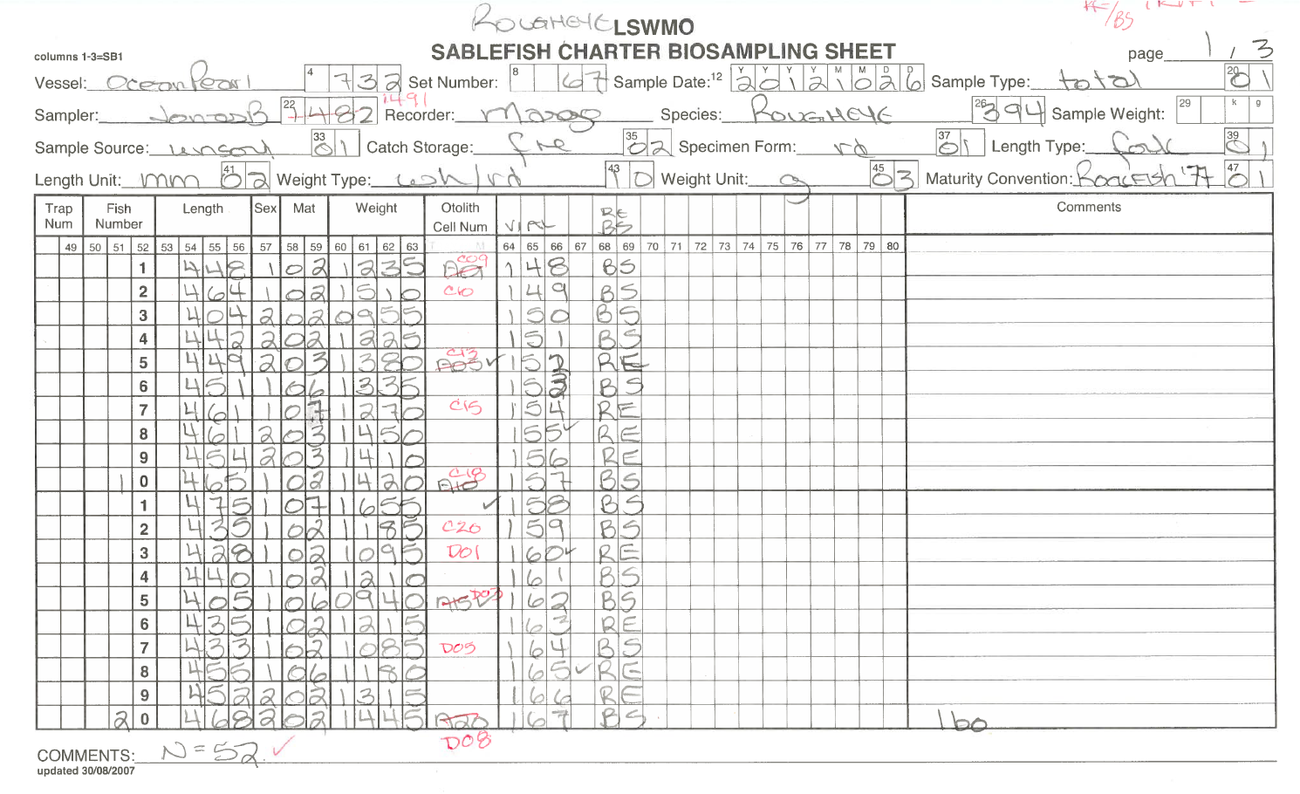

Figure C. 7. Example of a completed Rougheye Rockfish biological sampling form of the type used during the 2012 survey for LSWMO(DNA) samples.

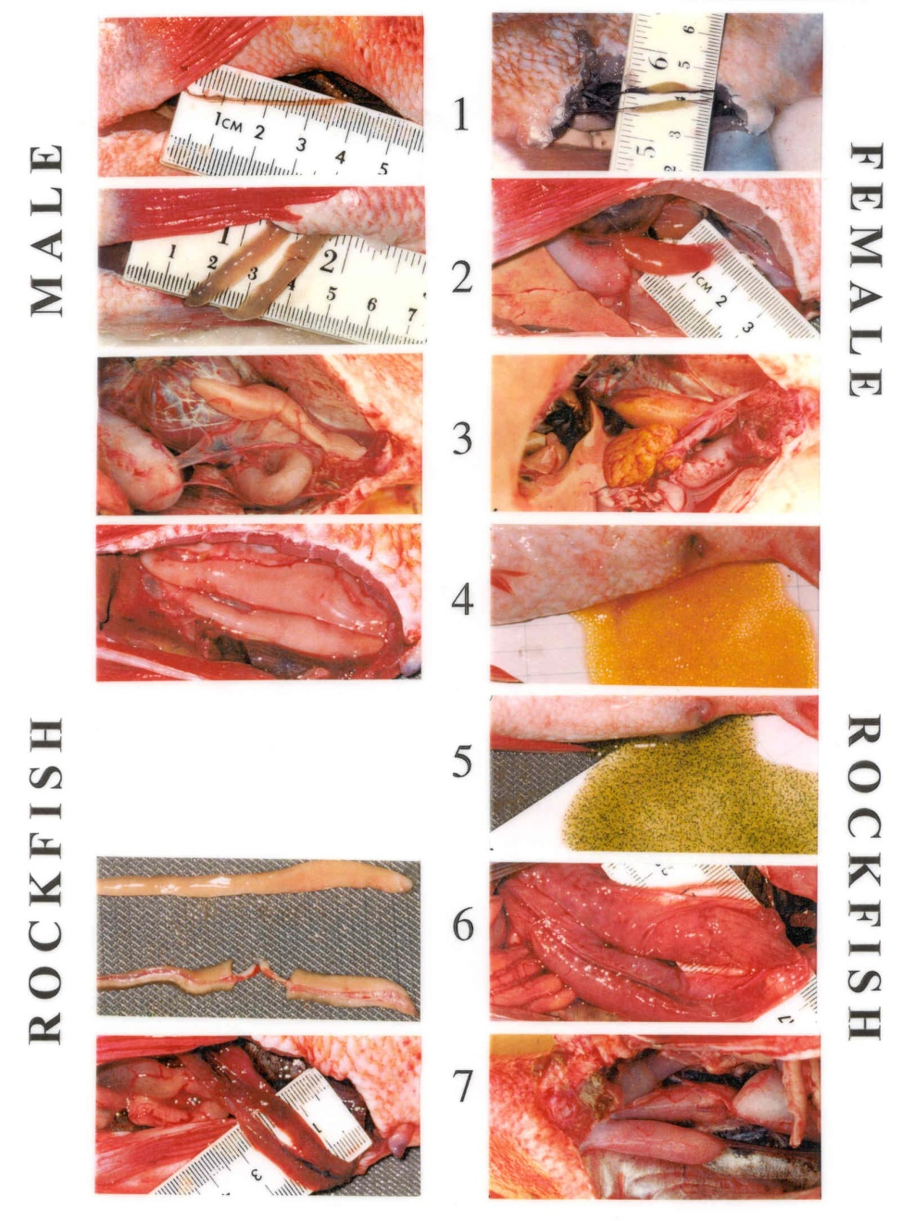

Figure C. 8. Rockfish maturity codes and corresponding images.

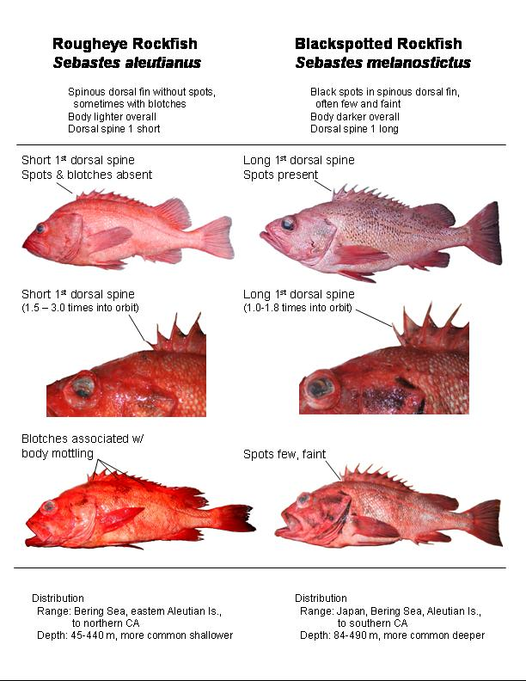

Figure C. 9. Example of the Rougheye\Blackspotted complex species identification form.

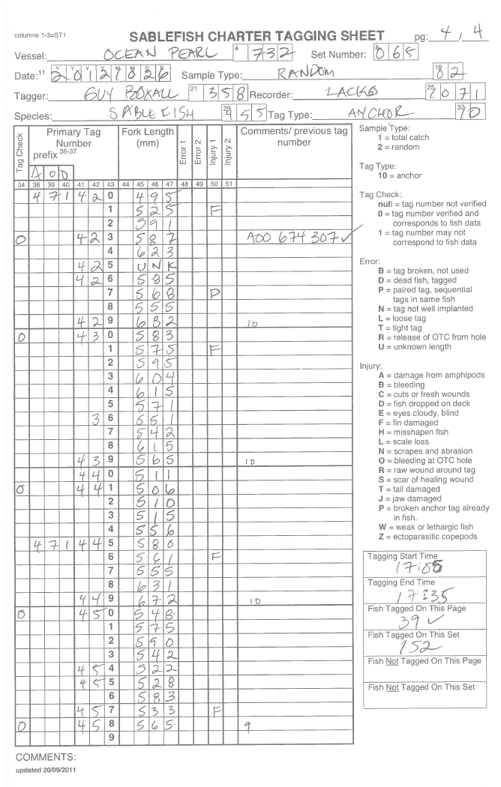

Figure C. 10. Example of a completed tagging form of the type used during the 2012 survey.

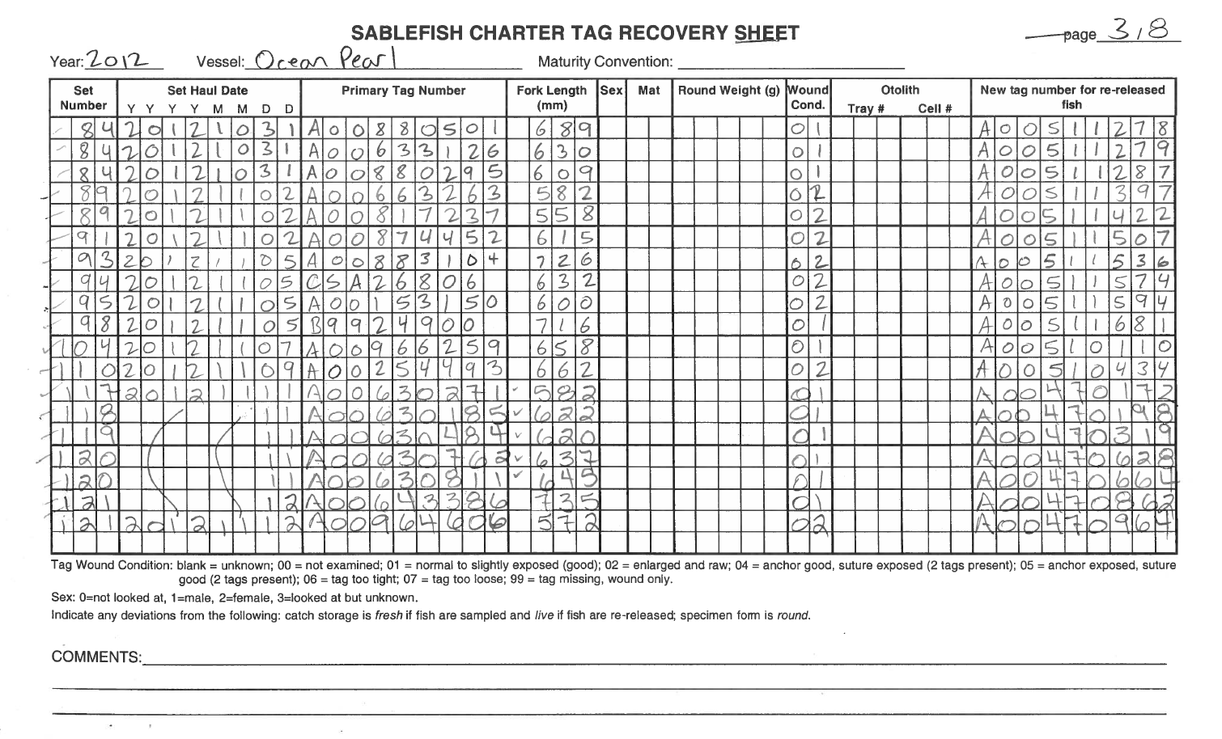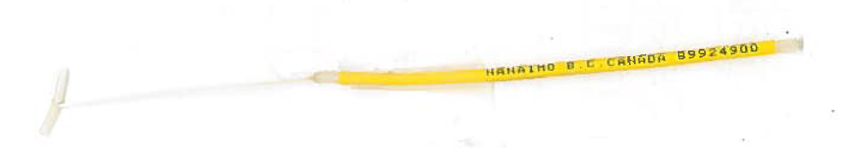

Figure C. 11. Example of a completed tag recovery form of the type used during the 2012 survey. The inset shows an example of recovered tag B9924900.

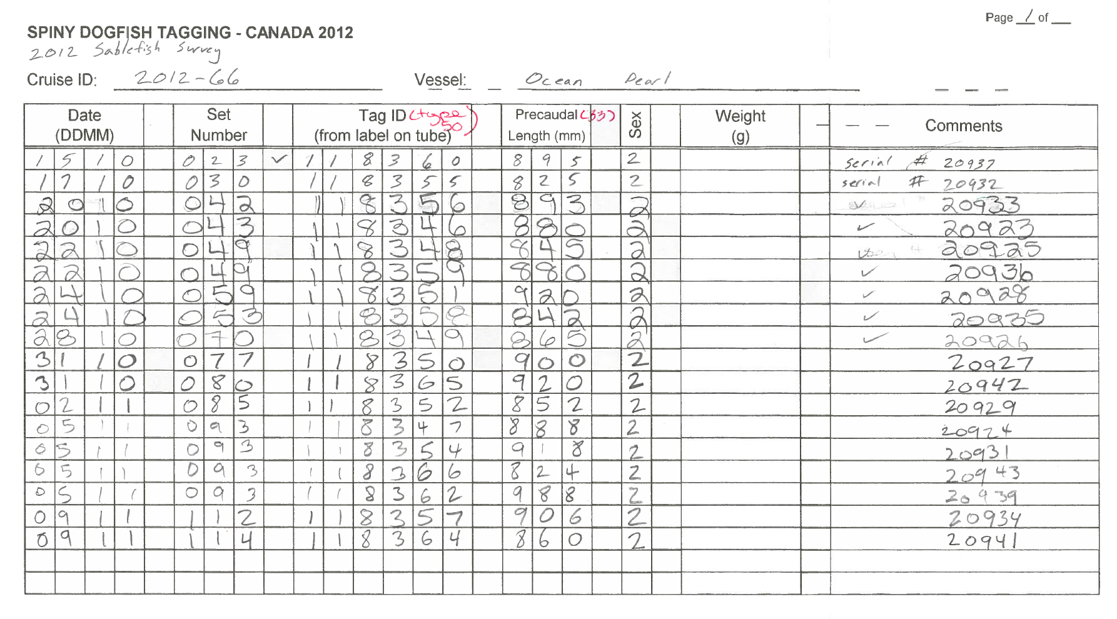

Figure C. 12. Example of a spiny dogfish tagging sheet of the type used in the 2012 survey.



Figure C. . Pop-off satellite tagging instructions for spiny dogfish



Figure C. 13. Continued.

Appendix D.Summary trap use for each set in the 2012 Sablefish survey.

Set numbers highlighted in green indicate standardized sets at mainland inlet localities and set numbers highlighted in blue are exploratory sets. All other sets are of the StRS type. Sets 6, 7 and 26 were video sets where cameras were attached to traps and are not included in this appendix. The fate of the Sablefish catch for each set and trap is indicated using the following abbreviations:

**Code             Sablefish use category                                                    
D**              Discarded after weighing (processed as commercial catch)  
**A**              Sampled for LSM(W)O  
**T**              Tagged and released  
**-**         No Sablefish catch/Trap missing or not fished



Appendix D**.** Continued.



Appendix D**.** Continued.



Appendix D**.** Continued.



Appendix D**.** Continued.



Appendix E. Example of a temperature and pressure data plotted over time with Sea-Bird Electronics© Plot 39 software.



Appendix F. Conversion of pressure to depth documentation from the Sea-Bird application note No.69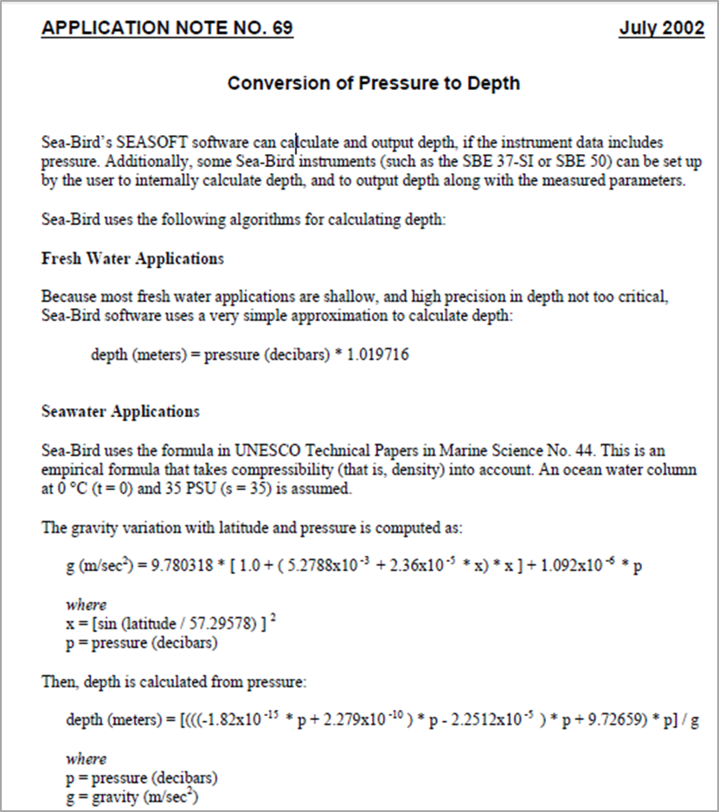. http://www.seabird.com/application_notes/an69.htm.

Appendix G. Instructions for deployment and uploading data from the Nuytco autonomous camera system.

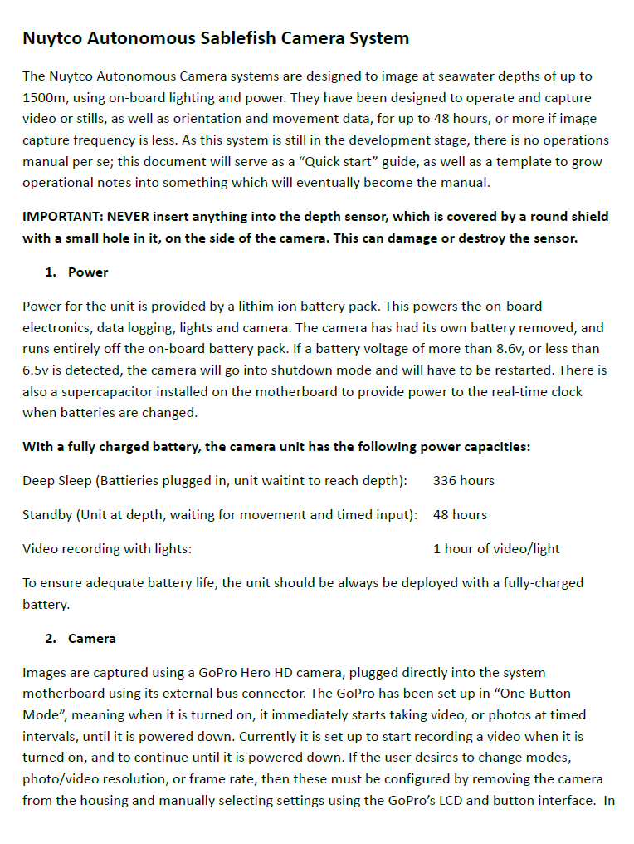

Appendix G. Continued.

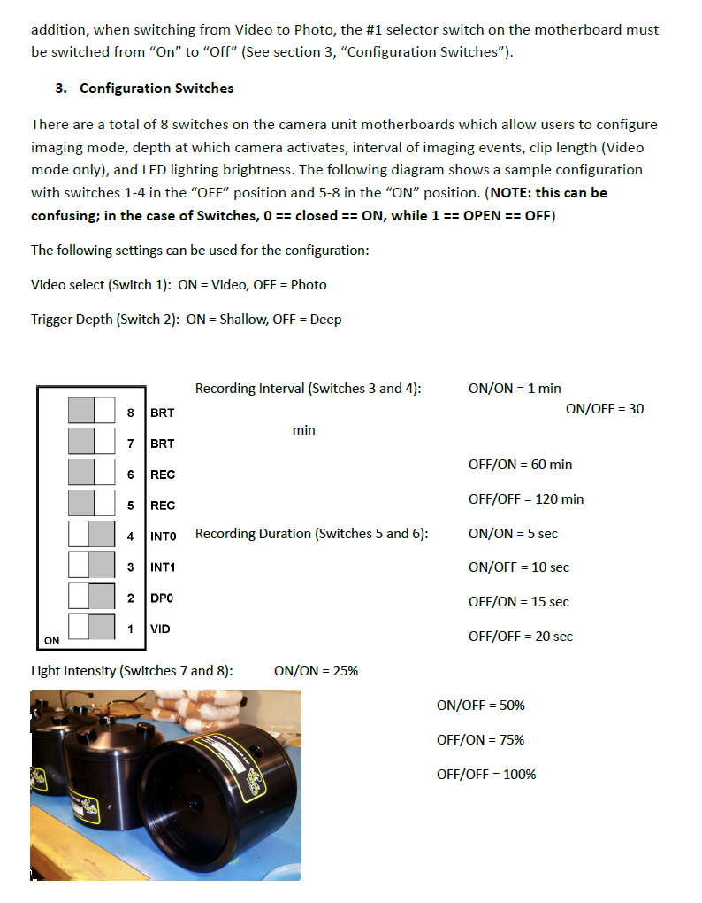

Appendix G. Continued.

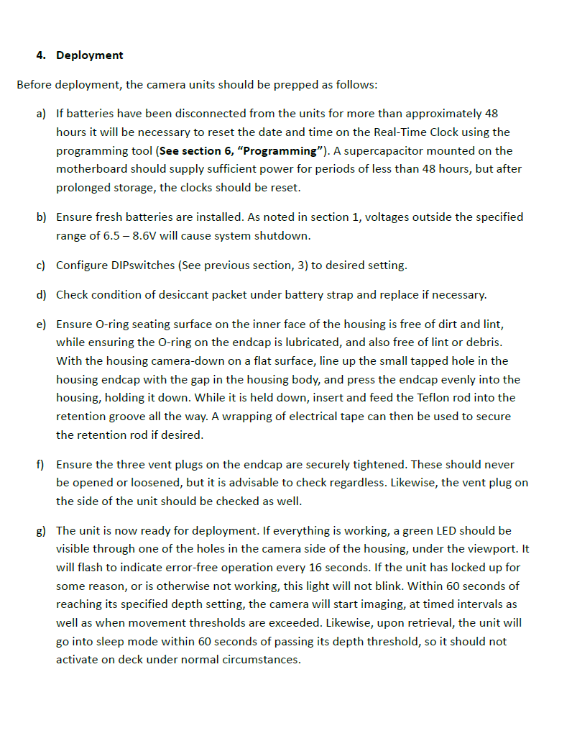

Appendix G. Continued.

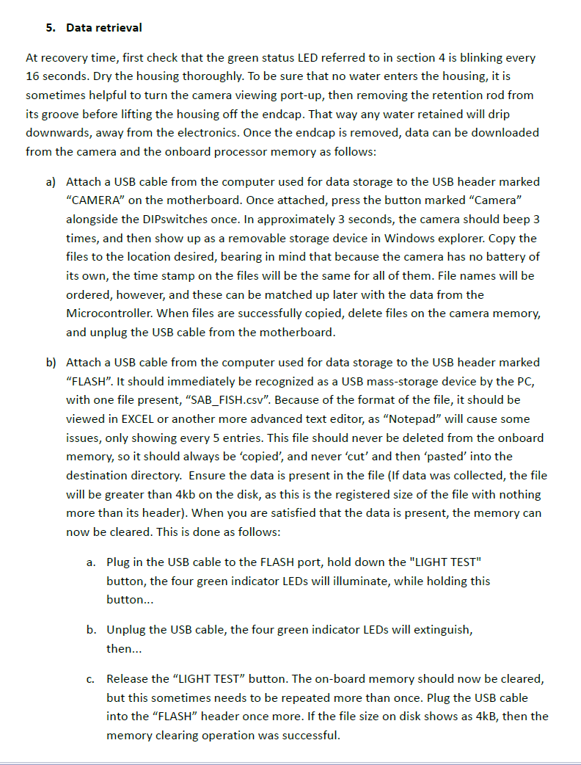

Appendix G. Continued.

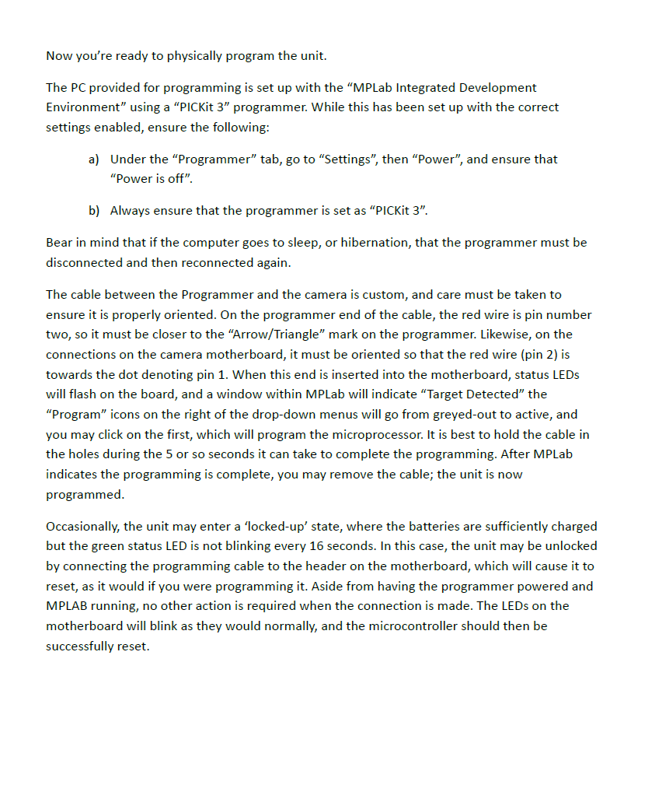

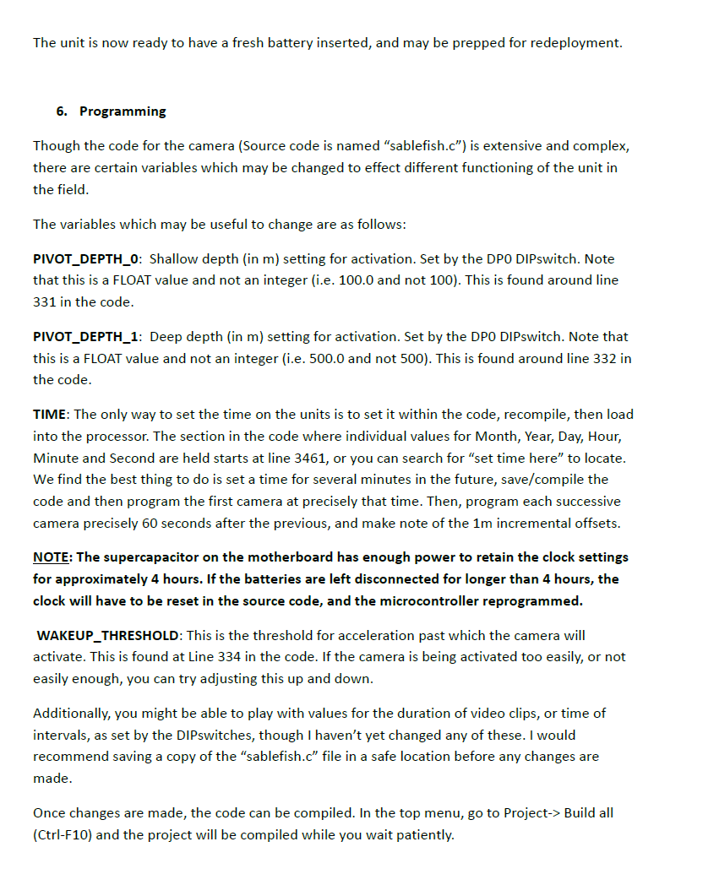Appendix G. Continued.

Appendix H. Example of a plot using HOBOware© Lite Software. The data table displays the date, time, X, Y and Z acceleration in units of g-force (m/s2). The graph shows the x, y and z readings over time, with the time of the last anchor being set over the stern and the first anchor hauled aboard marked between the arrows.



Appendix . Details on Sablefish catch and numbers recovered, sampled and tagged during the 2012 charter.



Appendix I. Continued.



Appendix I. Continued.



Appendix I. Continued.



Appendix J. Trap Gear Glossary.

**Anchor**: Bundle of chains weighing approximately 60 kg (90 lb) that is attached to the

groundline on the becket before the first trap and after the last trap. The anchors prevent drifting and sliding of the groundline.

**Anchorline or buoyline**: A 549 m (300 fm) long 22 mm (7/8 in.) 3-ply polypropylene rope permanently attached to the groundline at the first and last becket. This line retrieves the anchor and groundline.

**Baitbag**: 15 x 20 cm (6 x 8 in.) 3.175 mm (1/8 in.) mesh bag with a nylon drawstring and no. 72 stainless steel halibut longline snap.

**Becket**: 13 mm (1/2 in.) diameter two-in-one braided nylon rope spliced into the groundline every 46 m (150 ft). Each becket forms a loop of approximately 15 cm (6 in.).

**Buoy**: 60 to 90 cm (2 to 3 ft) diameter Bright orange inflatable plastic bladders used in

combinations of two or three to suspend the sinkerline and buoyline.

**Bridle**: 13 mm (1/2 in.) 3-ply polypropylene rope "double" fastened at three points to the top hoop of the trap and knotted at a single point to form a loop of approximately 158 cm (62 in.) long with a snap bent on to the end. This bridle is fastened onto the top hoop in such a manner that pressure is inward on the tunnel when the trap is being retrieved.

**Drum**: Large capacity spool or drum that stores 3 to 5 complete anchor and groundline

combinations.

**Escape panel**: 12 meshes of the trap web located in the upper half of one of the panels opposite the tunnel and cut along the horizontal bar to make a triangular opening of approximately 25 cm (l0 in.) when allowed to hang loose. The cut is laced closed with a single piece of 2 mm cotton "butcher" twine. The purpose of the panel is to create an opening when the cotton twine rots if the trap is lost while fishing, i.e., to prevent ghost-fishing.

**Flagpole**: Attached to buoys and helps to locate the end of the string.

**Groundline**: 22 mm (7/8 in.) 3 ply polypropylene rope of various lengths depending on the depth of the set.

**Hauler or power block**: Hydraulic powered pulley that hauls all the line at approximately 30 m (100 ft) per minute aboard the vessel prior to winding or storing on the drum.

**Ring**: 52 mm (2 in.) diameter 8 mm (5/16 in.) stainless steel ring bent or knotted onto becket.

**Shotline**: Additional pieces of 22 mm (7/8 in.) polypropylene rope used to extend the anchor or buoyline, usually 91 m (50 fm) or 183 m (100 fm) long.

**Sinkerline**: 19 mm (3/4 in.) 3-ply nylon rope attached to the top of the buoyline or shotlines. The purpose of this line is to prevent the polypropylene anchor or buoyline from floating and "puddling" on the surface and posing a hazard to navigation. The line is usually 9l m (50 fm) or 183 m (100 fm) long.

**Snap**: Galvanised cast steel device with ring on one end and a spring loaded enclosure on the other end strong enough to withstand a 1400 kg (3000 lb) strain.

**Traps**: The traps are a Korean design adopted and modified by local fishers to local conditions. They are designed and constructed to stack into each other when transported or stored. The traps are constructed of mild steel rod welded at all junctures. The top hoop diameter is 84 cm (33 in.), the bottom hoop diameter is 137.2 cm (54 in.), and the 6 vertical members are 79 cm (31 in.) long giving the trap a 74 cm (29 in.) vertical height. Horizontal bars are attached midway between the top and bottom hoops in 5 of the 6 vertical panels. The trap is covered or caped with a single piece of black nylon #48 thread 70 mm web (measured inside the knots when the web is stretched flat). This is fastened to the frame so that the top is permanently closed and the bottom can be opened and closed with a draw string. The one side panel without a horizontal bar is not covered with web and accommodates the trap entrance or tunnel. The tunnel is constructed of two pieces of green 44 mm (#18) knotless braided web. The two seams of the tunnel are fastened together prior to attaching to the frame of the trap. When the tunnel is fastened to the trap it slopes downward with a 36 cm (14 in.) opening or slit. The bottom part of the slit will be taut and the top will be loose when the tunnel is stretched into place from the opposite panel of the trap. The tunnel extends 64 cm (25 in.) into the trap. When the trap is prepared for fishing both the tunnel lines and the bottom closing line (4 mm braided single-ply polypropylene twine) are pulled taut, looped together and knotted at a single point. The tunnel and bottom closing lines are of sufficient length to allow the bottom and the tunnel to collapse completely against the inside of the trap to allow for stacking. One of the panels opposite the tunnel contains the escape panel (defined above). Chafing line (10 mm (3/8 in.) and 13 mm (1/2 in.) diameter 3-ply polypropylene) is wrapped around all the frame members to protect the web after the trap is covered.

(Descriptions were modified from Smith et al. 1996)